Le passé composé

Objectives:
- Revising how to form the perfect
- Using ‘à’ + definite article (if time allows or is needed)

Duration: 10 minutes

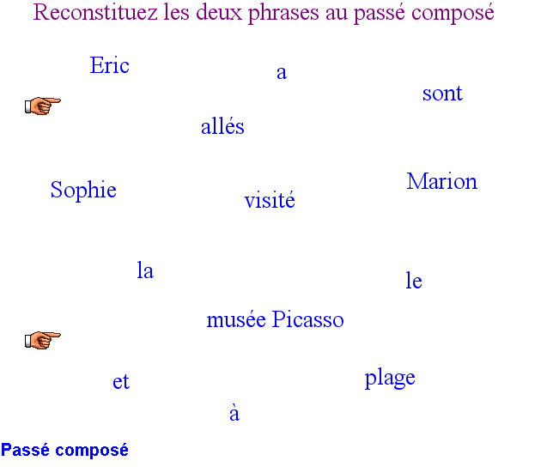
Suggested approach:
- Split the students into 2 or 4 pairs/groups. Ask groups to reconstitute the two sentences from the elements on the board. They need to be prepared to be quizzed on their choices by another group.
- Send group A to visit group B and exchange views on what the two correct sentences are. Are there alternatives? Why aren’t ‘à’ and ‘a’ interchangeable? Why the use of ‘avoir’ in one case and ‘être’ in the other? Why can’t it be ‘Sophie et Marion sont allés’ etc ?If necessary prompt students to reflect on these.
- In plenary, clarify with students how to form the passé composé.

Elluminate tips: The title and the hands are fixed. Refer to the Quick Elluminate Guide if you need to unfix them. The other objects can be dragged to make up the sentences.

