WHY STUDY HUNGARIAN? AN INTRODUCTION TO LANGUAGE AND CULTURE
FOR BEGINNERS AND MORE ADVANCED LEARNERS

This work sheet is divided into two parts. Before starting to work on either of them, students should listen to the following video recording, in which two students explain why they decided to learn Hungarian at university and what their understanding of the language is like.
http://www.youtube.com/watch?v=cHYR7vLVUmY

- „If Hungarian were a drug, it would be a magic mushroom”
Material recommended for students beginning their study of Hungarian.
The students explain in the video why they decided to learn Hungarian. One of them quotes his professor of linguistics who said that if Hungarian was a drug, it would be a magic mushroom. From the students’ description of the language how do you think this comparison is justified? What do you learn about the structure of Hungarian from what they say? What kind of language is Hungarian in their opinion?
At the end of the video, one of the students reads István Örkény’s short story entitled Fűre lépni tilos which means ’It is forbidden to step on the grass’:
fű-re = ’grass’-onto;
lép-ni = ’step’-infinitive = to step;
tilos: ’it is forbidden/not allowed’.
You can read the entire text below:
A fűre lépni tilos
tilos a fűre lépni
lépni tilos lépni
lépni lépni lépni
lépni tilos tilos
tilos tilos tilos.
Tilos.

Now listen to a native speaker reading the same text. Do you discover any differences especially in pronunciation and intonation? What are these differences?

Below are a few prohibitive signs which you usually come across in Hungary. What do they forbid?

TILOS A DOHÁNYZÁS. TILOS KIHAJOLNI.

A MOBILTELEFONOK HASZNÁLATA TILOS.

A VÉCÉK HASZNÁLATA TILOS, AMÍG A VONAT ÁLLÓ HELYZETBEN VAN.

dohányzik = ’s/he smokes’ => dohányz-ás = dohányzás ’smoking’;
kihajol = ’s/he bends (over a fence or window)’ => kihajol-ni = kihajolni ’bending over’;
használ = ’s/he uses’ => használ-at = használat ’usage’;
amíg a vonat álló helyzetben van = ’while the train is standing at the station’

Look at the following sign post. What are we not allowed to do in this area? Use the expressions given below the picture in your answer:

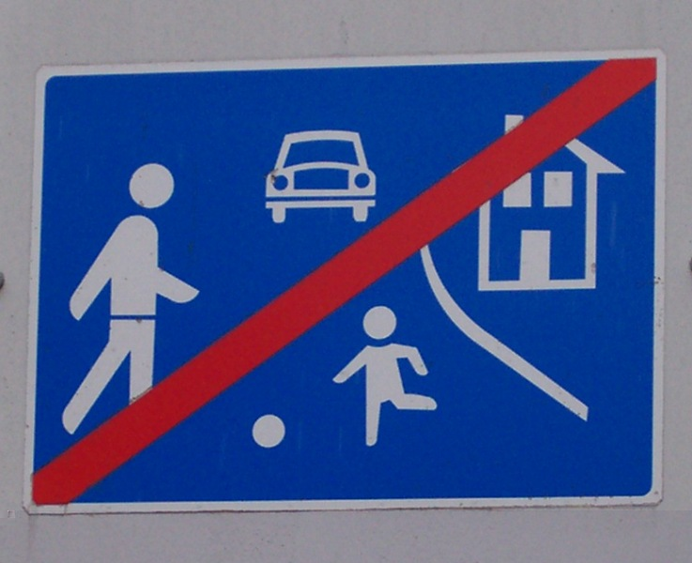

You may have to change some of these wordes in order to be able to use them with tilos. Follow the pattern in the examples above when chancing verbs to nouns and verbs to infinitives.
focizik = ‘s/he plays football’; játszik ‘s/he plays’; vezet ‘s/he drives’; fut ‘s/he runs’; autó ‘car’;
labda ‘ball’ > labdázik ‘s/he plays with a ball’; a házban lakik = ‘s/he loves in the house’;

- How do words come into being?
Material recommended for students progressing from beginner to intermediate level or above.
Watch the short film under the above link to find out what English-native speaking university students’ favourite Hungarian words are. Do you know any of these words?¹
Below you have a few short definitions in Hungarian. Read the definitions and decide which favourite Hungarian word from the video they describe.
- Valaki, általában egy férfi, aki nagyon szereti a nőket, és nagyon szereti elcsábítani a nőket.
- Majdnem nevet, de nem hangosan, hanem csendesen. Mosolyogni kezd.
- Az a része egy társasháznak, ahol az emberek feljutnak a lakásukhoz. A lépcső van itt.
¹The words they list are lépcsőház, nőcsábász, elmosolyodik, papucs, halálhörgés.
- Compounding
Among these, the compounds are made up of the following parts:
lépcső+ház = ’stairs’ + ’house’ => lépcsőház = ?
nő+csáb[ít]-ász = ’woman’+’charms’-suffix meaning ’word for occupation’ => nőcsábász = ?
halál+hör[ö]g-és = ’death’+’rattles’-suffix turning nouns into verbs => halálhörgés = ?
Can you predict the meaning of the whole word from this analysis?
What do you think the following compounds mean?
földrajz = föld+rajz = ’earth, soil, floor’+’drawing’ = ?
háromszög = három+szög = ’three’+’angle’ = ?
Földközi (tenger) = föld-köz[ött]-i (tenger) = ’earth’+’between, middle, mid-’ (sea) = ?
What do you think of the English translations of these words? Do they look like English words? Do they consist of one meaningful element or several elements?
The Hungarian verb él means ’lives’ and the noun élet means ’life’. Based on what you learnt above, what do you think the compound életrajz means? What about önéletrajz, in which ön- means ’self’?
The endings –ász and –és will be discussed in section 3 on derivation below.
The remaining two words are either borrowings (papucs, from Turkic, ’slippers’) or derivations within Hungarian: mosoly = ’smile’ => el-mosoly-odik ’smiles, breaks into a smile’

- Borrowing
Do you know any English words that are borrowings from other languages?
From which languages were the following words borrowed? What do you think? There is an odd one out, which is not a borrowing but a word (in fact a compound) that already existed in Old English.
pizza admire table pasta tragedy island doubt
coach dramatic robot frank(ly) argue polemic peninsula
Can you guess what the following Hungarian words, borrowed from English, mean?
szendvics szájt dzseki menedzser hoki tinédzser fájl
míting sms futbal[ozik] dzsessz gól szörf hemendex medzsbox
- Derivation
In the Hungarian verb elmosolyodik we find at least four morphemes (above only three of these were shown separately). Morphemes are elements of language that we think of as having a meaning of their own (for example the word smile consists of one morpheme); this meaning can be grammatical as well: think of the difference between smile and smiles or smiled. We tend to think of smile as a word, while everyone would agree that –s in smile-s and –d in smile-d are not words. Despite the fact that these elements are not thought of as words with a meaning of their own, it is obvious that they modify the meaning of smile substantially. Elements of language which either have a meaning of their own (a lexical meaning) or they modify the meaning of other words substantially (thus they have a grammatical function) are called morphemes: they may have a lexical or grammatical meaning of their own. Can you mention some other grammatical morphemes in English?
The Hungarian morphemes –és and –ász, encountered in section 1 on compounding, are used to build new words from existing ones. They both have a front and a back vowel variety: -ás/és and -ász/ész.
-ás/és usually mean ’the action of doing something’ while -ász/ész form names of professions. Observe the following examples and then try to guess the meaning of the remaining ones:
vad ’wild, game’ => vadász ’hunter’;
kert ’garden’ => kertész ’gardener’;
csillag ’star’ => csillagász = ___________________________
épít ’builds’ => építész = ____________________________
olvas ’reads’ => olvasás = reading;
kés[ik] ’someone is late, is delayed’ => késés = ’delay’;
hallgat ’falls silent, listens’ => hallgatás = _________________________
kér ’asks for something, makes a request’ => kérés = _______________________
From the verbs whose meaning is given below guess how we say the nouns in Hungarian:
ír ’writes’ => _________________________________ ’writing, a piece of writing’
beszélget ’talks, chats’ => ______________________________ ’a conversation, discussion’
lát ’sees’ => ____________________________ ’vision, someone’s ability to see’
főz ’cooks’ => _________________________ ’cooking, the making of a meal’
esik ’falls’ => _________________________ ’the falling off/over of something, someone’
From the nouns whose meaning is given below guess how we say the following professions in Hungarian or what the Hungarian profession names might mean:
tenger ’sea’ => _________________________ ’seaman, sailor’
madár ’bird’ => madarász ’_____________________’
hal ’fish’ => __________________________ ’fisherman’
szem ’eye’ => szemész ’_________________________’
seb ’wound’ => ______________________ ’surgeon’
bánya ’mine’ => bányász ’________________________’
lélek ’soul’ => lelkész ’_________________________’

Can you find English words which consist of three or more morphemes?
Such words made up of many morphemes are much more frequent in Hungarian than in English.
Here is a short list of suffixes which help create new words: -ó/ő, -ság/ség, -(z)ik, -t(a)lan/t(e)len, -at/et.
Discuss with your teacher what the most important function of these suffixes is and/or try to find examples in your dictionary.

