Fast facts about Hungarian

Did you know that…

- … Hungarian is a non-Indo-European language and the languages most closely related to it are Vogul (Mansi) and Ostjak (Khanty), which are spoken in Western Siberia?
- ... that Hungarian and these language belong to a group which is called Uralic, and which takes its name from the Ural mountains which separate Europe from Asia geographically?
- … in Europe only Finnish, Estonian, and Saami (Lapp) are related to Hungarian?
- … in Hungarian there are no prepositions, which are little words like at, on, in, to, or pronouns such as me, her, him, them, us, so Hungarian has to use endings (suffixes) which are attached to the end of words?
- … that the rules of attaching these endings are summarised in a grammatical concept which is called vowel harmony?
- … that Hungarian has very few exceptions, so, although it might seem hard to learn it at the beginning but once you learnt some basic rules it gets easier and easier? It is like a puzzle, really.
- … that Hungarian is spoken not only in Hungary but also in some parts of the countries surrounding it, such as Romania, Serbia, Croatia, Slovakia, and Slovenia?

Why is Hungarian exciting?

- Because it is a fascinating amalgamation of European and non-European language features, thus it is intellectually stimulating.
- Because it is refreshing to acquire a new language which is different from the more widely spoken Latin, Germanic, and Slavonic languages.
- Because there are very few exceptions in Hungarian and the complexities of the grammar are very transparent, so there is no need to memorise lengthy word lists and declination or conjugation tables.
- Because some 18 million people speak a Uralic language within the European Union and among these Hungarian is the largest one (approximately 13 million speakers).
- Because it combines well with German and Slavonic languages or Romanian if you want to study the history and culture of Central and Eastern Europe.
- Because there are very few English native speakers who know Hungarian, thus it is a very marketable skill and it is increasingly highly valued among employers in the UK and Europe.
- Because knowing a less-widely taught language, if you already have studied a major language, like German, Spanish, or French, will give you a competitive edge whether you wish to work with language or not.

Uralic languages: sub-groups and geography

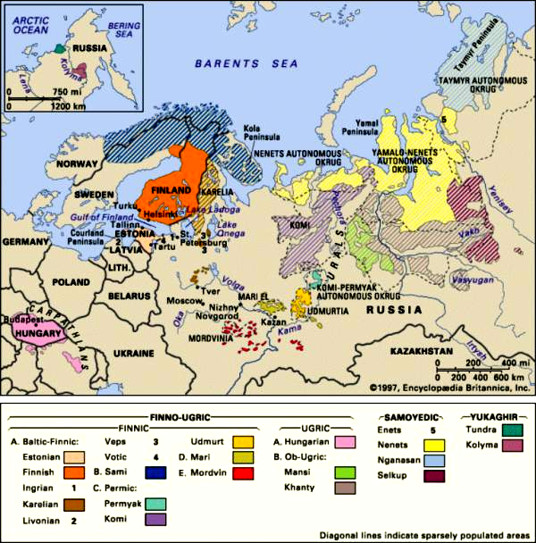

Can you place the languages you have studied on a similar map of Europe? Which language groups are you familiar with?

Mapping the languages of Europe

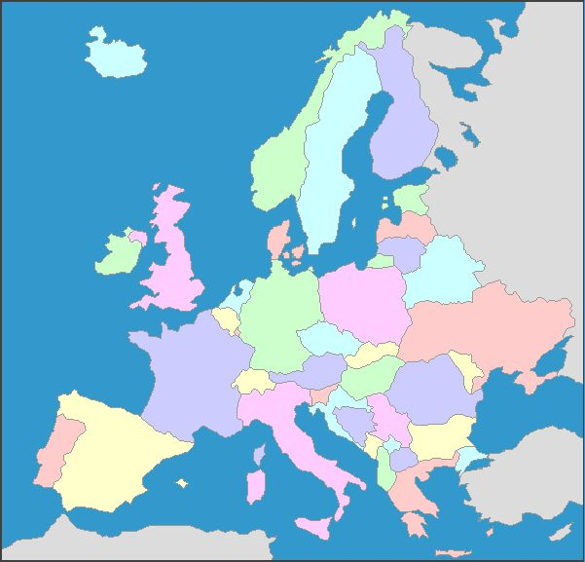
Map adapted from http://www.yourchildlearns.com/geography.htm

The following languages belong to one of the Indo-European language groups listed below. Into which group would you place them?

German, French, Romanian, Serbian, English, Farsi, Spanish, Slovak, Gujarati, Swedish, Danish, Hindi, Portuguese, Polish, Russian, Romani

Neo-Latin or Romance | Germanic | Slavonic | Indo-Iranian
French | German | Serbian | Farsi

Which other languages do you know from school or from home? Is it possible to place those in this table? Why? Mention, if you can, one more language for each group.

Now try to place those languages that are spoken in Europe on the map above. Do you discover a geographic connection between languages belonging to the same group?

The distribution of Hungarian in the Carpathian basin in Central-Eastern Europe
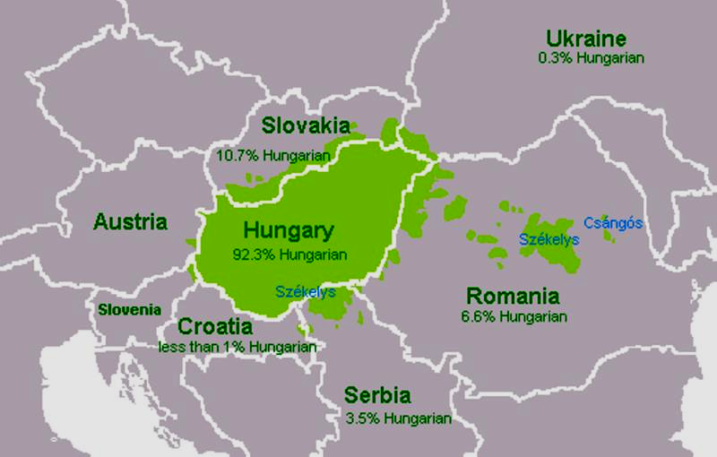

Some forms of greeting in Hungarian:

Opener during the day All-purpose closer
Formal Jónapot (kívánok)! Viszontlátásra! / Viszlát!
‘(I wish you a) good day! (Aurevoir! ‘See you soon!’)

To one person To more than one person
Informal Szia! / Heló! Sziasztok! / Helósztok!
‘Hello!’ ‘Bye-bye!’

Surprisingly, Hungarians can greet each other by saying Szia! and bid farewell by saying Heló!
How is this possible?
Well-known words in Hungarian: fast track to reading

Try to guess what the following words mean and which English word is ’hidden’ in them:
Amerika kávé csokoládé tinédzser kompjúter
Európai Unió posta szendvics menedzser fájl
kontinens metró hemendeksz medzsbox szájt

It might help if you try to pronounce the words, using the pronunciation guide below.

Pronunciation guide:

Consonants
Hungarian letter English sound which is similar to the Hungarian
C always [ts] as in lots and never [k]
Cs [ch] as in chocolate
G always [g] as in go and never as in [ge]
Gy [du] as in due, duke
J always [y] as in yes and never as in joke
Ly [y] same as <j>
K [k] as in key
Ny [nu] as in nude
R as in Spanish, Italian and modern Greek
S always [sh] as in shoe, shine
Sz always [s] as in sock
Ty [tu] as in tulip, Tudor
Zs [su] as in measure, pleasure
Dzs [ge] as in German
P, T and K are unaspirated

Vowels (the English equivalents are just approximations)
Hungarian letter English sound Longer variant
A [aw] as in British English art NONE
Á as the [i] in idol but without the [y]-sound NONE
E always [e] as in bed NONE
É [ay] as in May but without the [y]-sound NONE
I always [i] as in bid and never [ai] as in smile Í
O always [o] as in nod Ó
Ö [ur] or [er] as in nurse, slender without the [r] Ő
U [oo] as in food Ú
Ü try to say [i] as in bid but with round lips Ű

Introducing yourself in Hungarian:

(Én) _______________ vagyok. vagy-ok = ‘I am’, where -ok means ‘I’
(Te) _______________ vagy. vagy = ‘you are’
(Ő) ________________ ∅ there is no is in Hungarian, so for ‘she is happy’ they will simply say ‘she happy’ or just ‘happy’ = (ő) boldog

You can fill in the gap
1. with your name: Anna vagyok.
2. with your profession Diák vagyok diák = ‘student’
3. with your nationality: Angol vagyok. angol =’English’
Magyar vagy. magyar = ’Hungarian’
Ő tanár. tanár = ’teacher’

The verb beszél = ’speaks’ and tanul = ’studies’ and vowel harmony

beszél-ek = beszélek ’I speak’ tanul-ok = tanulok ’I study’
beszél-sz = beszélsz ’you speak’ tanul-sz = tanulsz ’you study’
beszél-∅ = beszél ‘s/he speaks’ tanul-∅ = tanul ‘s/he studies’

Beszélek angolUL ‘I (can) speak English’ Tanulok franciáUL ‘I (can) speak French’
Beszélsz angolul ‘you (can) speak English’ Beszélsz franciáUL ‘you (can) speak French’
Beszél angolul ‘s/he (can) speak English’ Beszél spanyolUL ‘s/he (can) speak Spanish’

What do you think the following sentences mean?

Magyarul tanulok. _______________________ Angol vagyok. _________________________
Tanulsz franciául? ________________________ Fizikus vagy? __________________________
Anna magyarul tanul. _____________________ Péter diplomata. _______________________
What do we mean by different types of languages?

- Can you guess what the following French sentence means, even if you have not studied French?
Au zoo, Michel admirait les girafes, mais il préférait les éléphants.
_____________________________________________________________________

What are the language features that make such guess work possible?
Write down the most plausible English translation of the sentence below the French, and compare the words and grammar (e.g. the plural ending). Now compare both with a Hungarian translation of the sentence:
Az állatkertben Mihály csodálta a zsiráfokat, de jobban szerette az elefántokat.
What are the linguistic and non-linguistic factors that might lead to such similarities and differences in language structure?

- What do we mean by a WORD?

How many words are there in the following English sentence? Is to a word?
I am going away for the school break with my brother to Scotland.
Now look at a possible Hungarian translation of this sentence:
Elutazom a szünidőre a bátyámmal Skóciába.
How many words can you count in this Hungarian sentence?
.... less than half. But each Hungarian word contains grammatical information which in English is expressed by separate words in writing. This is how it works:

I am going away | for the school break | with my brother | to Scotland.
El-utaz-om | a szün-idő-re | a bátyá-m-mal | Skóciá-ba.
away-go-I | the break-time-for | the brother-my-with | Scotland-to.

Hungarian is a type of language which is called agglutinating. This word is related to the English glue and gluing, and it reflects the fact that Hungarian is a different type of language from English and French, for example. Rather than using separate words to express grammatical meaning, it uses endings, or suffixes, which result in fewer words in a sentence, but words tend to be more complex because they carry grammatical meaning as well.

More on words – and culture:

Hungarian words are complex not only because they carry grammatical meaning but also because Hungarian often creates new words by adding endings to old words or to new words, which it had borrowed from other languages. Look at the following examples, in which you will recognise some of the words that were discussed earlier:

kávé ‘coffee’ => kávé-z-ik = kávézik ‘has/drinks coffee’
metró ‘underground’ => metró-z-ik = metrózik ‘travels on the underground’
posta ‘post office’ => postá-z-ik = postáz (egy levelet) ‘posts (a letter)’
medzsbox ‘matchbox [toy car]’ => medzsbox-oz-ik = medzsboxozik ‘plays with little cars’
szedvics ‘sandwich’ => szendvics-ez-ik = szendvicsezik ‘eats/has a sandwich’
kompjúter ‘computer’ => kompjúter-ez-ik = kompjúterezik ‘plays/works on a computer’

Based on the examples above, try to guess the meaning of the following Hungarian verbs:

emailezik:____________________________ teázik:______________________________
teniszezik:____________________________ gitározik: ___________________________
hamburgerezik:________________________ szörfözik:____________________________

What about the following verbs:

bor ‘wine’ => borozik:____________________ zongora ‘piano’ => zongorázik________________
sör ‘beer’ => sörözik:_____________________ emlék ‘memory’ => emlékezik________________

In many Hungarian swear words and cursing the word anya ‘mother’ features. Ways of swearing and expressions used for cursing are usually rooted in a given culture and the way the culture in question perceives the world around it. One of the most serious offenses in Hungarian is to be told anyád = anyá-d ‘mother-your’, that is, ‘your mother’
So, what might the following verb mean? anyázik:__________________________________

Another way of cursing is menj a francba = menj a franc-ba ‘go the franc-into’, where it is no longer possible to translate franc, but it used to mean ‘France’. The same word is used in a franc egye meg ‘may the franc eat him/her up’. But why would it be such a huge punishment to be sent to France...?

Try to read out the following expressions: ejnye-bejnye, lári-fári, irgum-burgum
Perhaps surprisingly, they are also ways of swearing. What do think, are the chief offences? With whom do you imagine they would be used? What makes you think that? Why are these expressions peculiar?

Language and culture

- Using what you have learnt about Hungarian so far, try to read out the following phrase:

AKKEZDET PHIAI

Does this look like a Hungarian phrase? Why or why not?
What if you knew it was from another language. How would you read it then?
Does spelling have to do with culture? Can you mention other examples from languages you know?

- According to Hungarian orthography, this would be spelled as A KEZDET FIAI, which means ‘sons of the beginning’. What could this be? The name of a shop? The title of a book? The name of an organisation? Or?

- Who do you think the people in the picture are? What might their job(s) be?

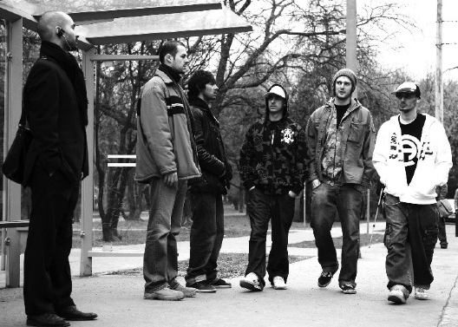

Could they be musicians? What kind of music they play?

- Listen to the track and try to pick up on any words you might understand.
- Based on the clip, what do you think the text is about?
- If you saw only the images and could not hear the rap, where would you place this track? Is it European or from somewhere else? Does hearing the music change this? How and why?
- In your opinion is there any mismatch between the images, and the music? Why would they have chosen still these images to complement the music? What does this tell you about the text even without understanding it?

Akkezdet Phiai rap track: Zenebuddhizmus

In the rap track there are a couple of lines written on a piece of paper:
A valósággal az a gáz, hogy nincs hozzá háttérzene.
– A kérdés, hogy átérzed-e.
which could be translated as:
To life there is no background music – too bad.
– What do you make of that?

How is this relevant to the images you saw in the clip?

Learning to rap in Hungarian:

And here is the refrain:

A lelked a dallam Your soul is a tune
A tested a ritmus Your body the rhythm
Az elme az rím The mind is a rhyme
Ez zenebuddhizmus ......

Based on these lines, what do you think makes a good text for rapping?

These lines are easy to rap in Hungarian, and, as you heard it while watching the clip, they give a beautiful rap tune. But do these rough translations work in the same way in English? Why (not)?

