Levoča
UNESCO listed town
Renesančná radnica Renaissance Town Hall
More information:
slovakia-travelguide.info/levoca.html
www.levoca.sk/icko.htm
travel.spectator.sme.sk/articles
Classical Music Festival “INDIAN SUMMER FESTIVAL” www.ibifestival.eu

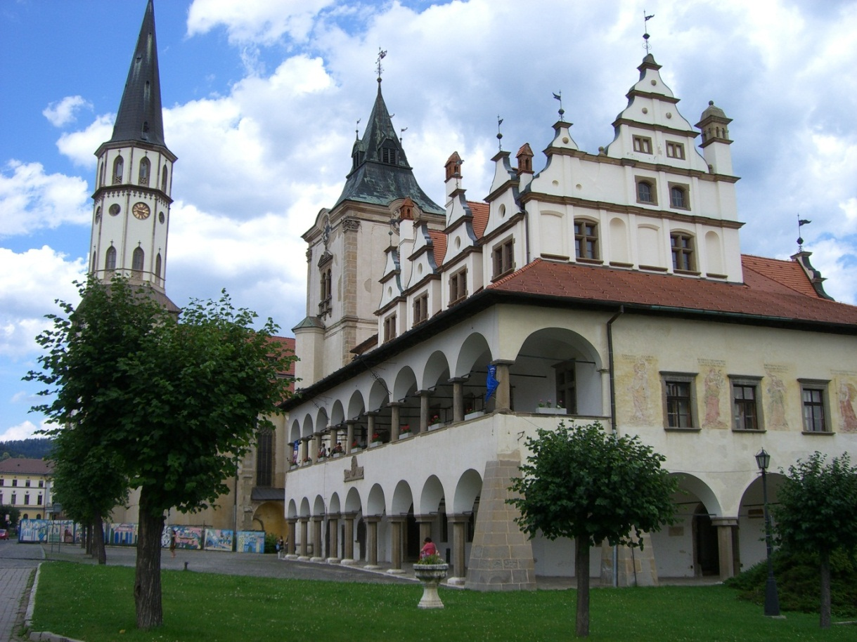
Photo: Olga Willett

