Word jumble
On the ‘cards’ you see here are the names of some common household objects and furniture. Each of them will ‘fit’ into a particular place on the plan of Baiba’s and Guntis’ flat in Riga. See if you can place them all, by marking the items on the cards with the appropriate numbers from the floor plan below.
Items Rooms
ledusskapis refrigerator  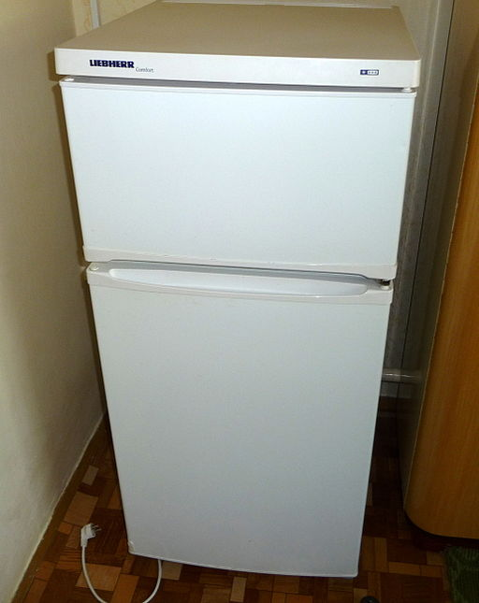 | viesistaba living room  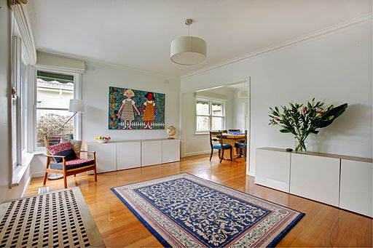
televīzors television set   | vannas istaba bathroom  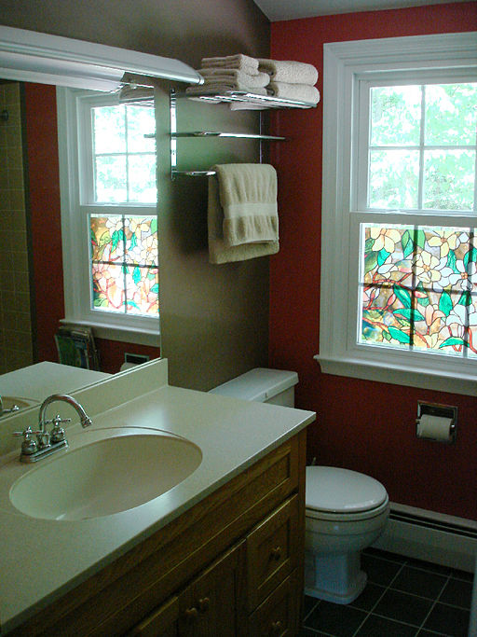
rakstamgalds desk  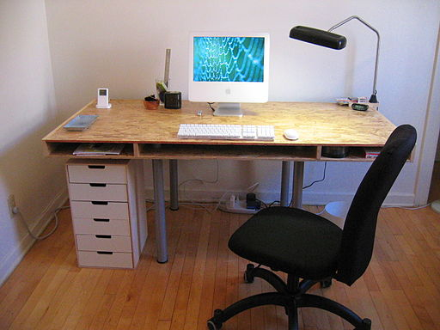 | skapis cupboard  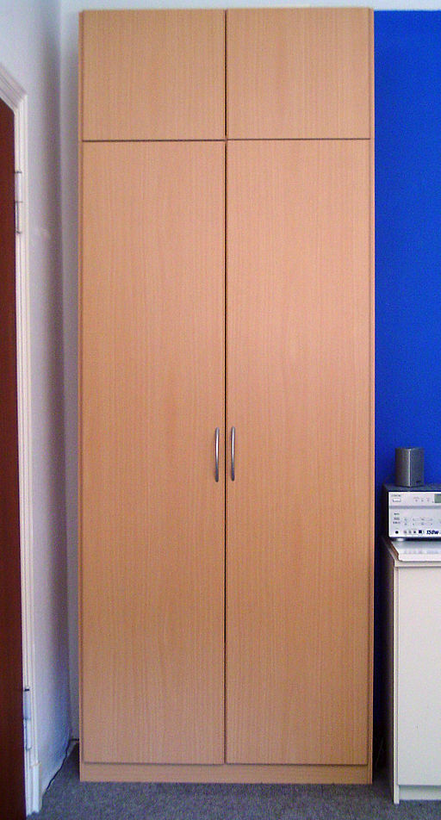
dators computer  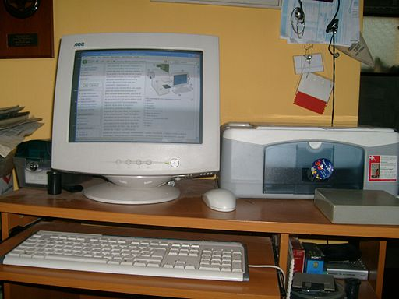 | tualete toilet  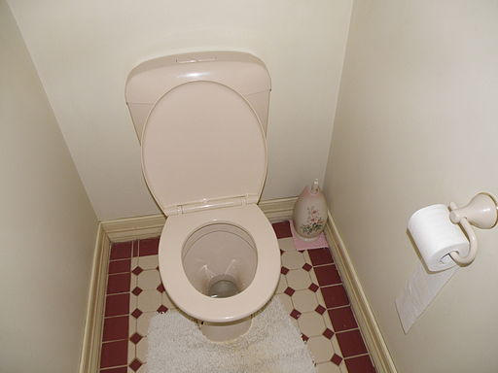
datorgalds computer desk  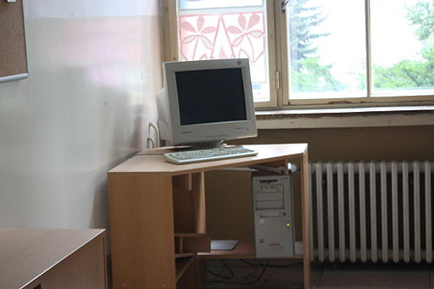 | virtuve kitchen  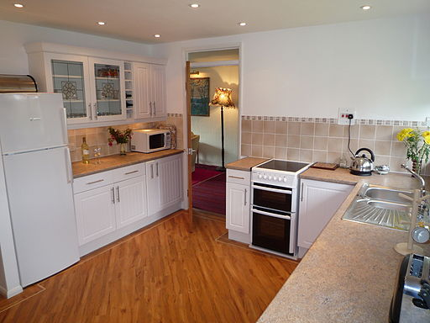
dīvāns sofa  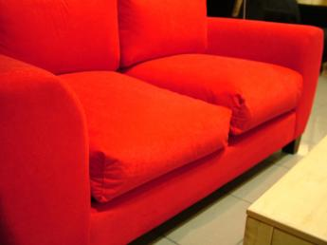 | paklājs rug, carpet  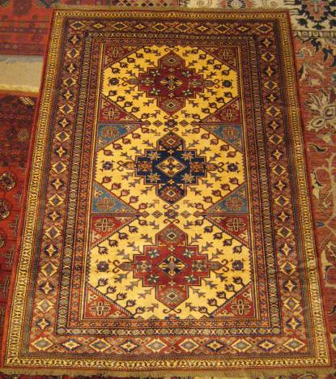
izlietne sink  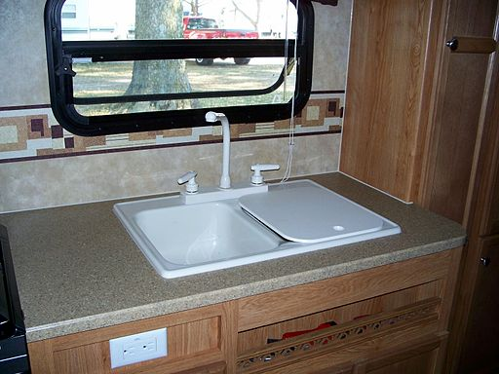 | bērnu guļamistaba children’s bedroom  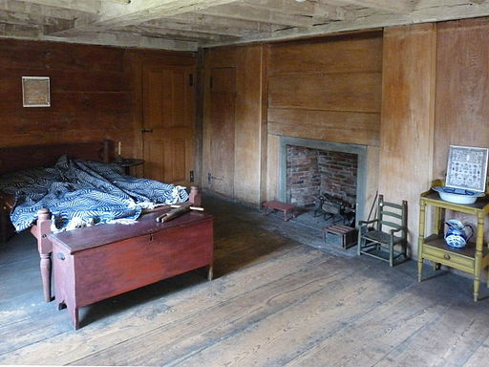
vanna bathtub  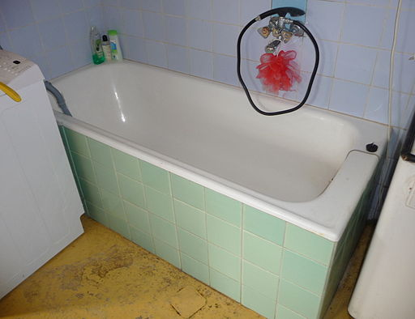 | spogulis mirror  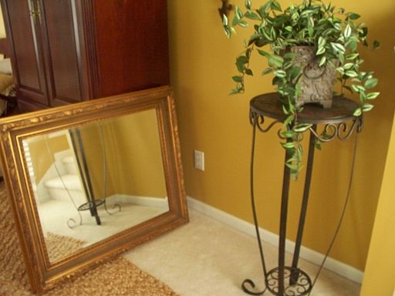
lampa lamp  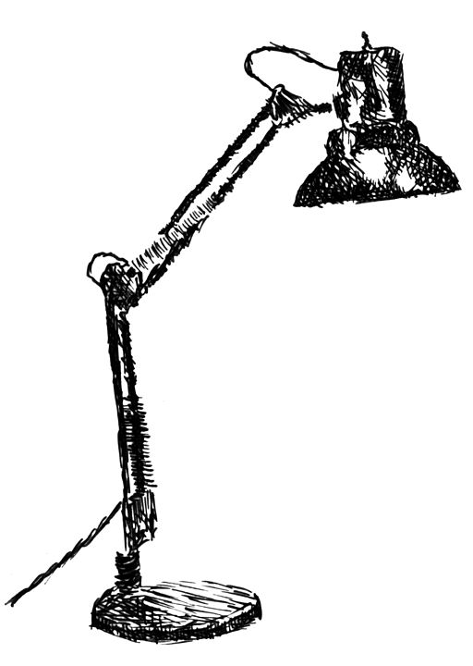 | guļamistaba bedroom  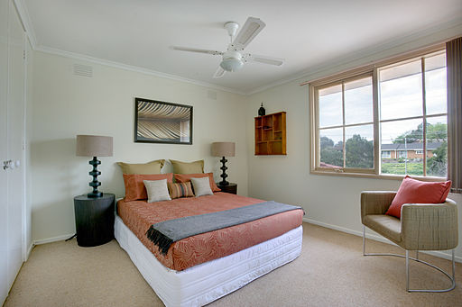
galds table
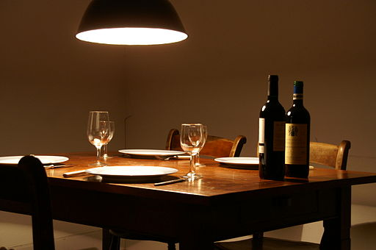

plīts oven
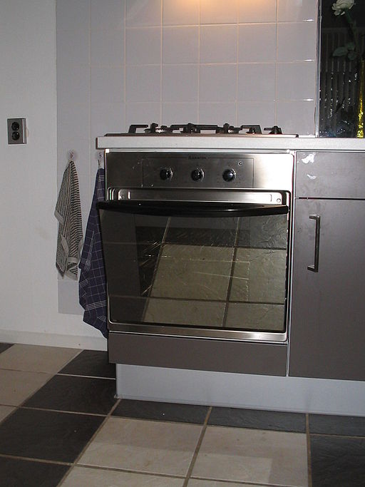

gulta bed
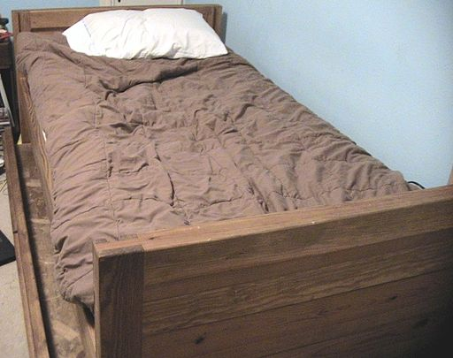

krēsls chair
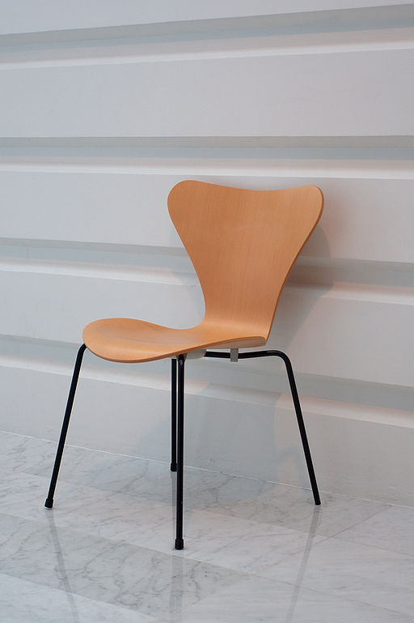

atpūtas krēsls armchair
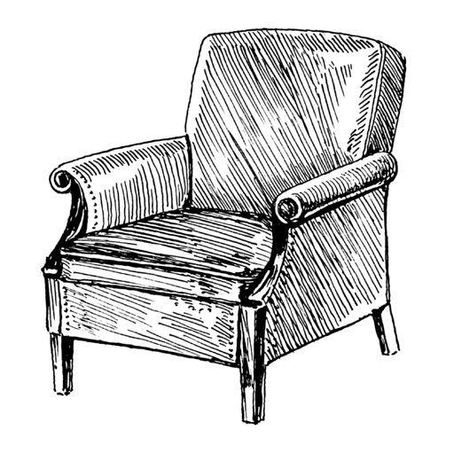

grīda floor
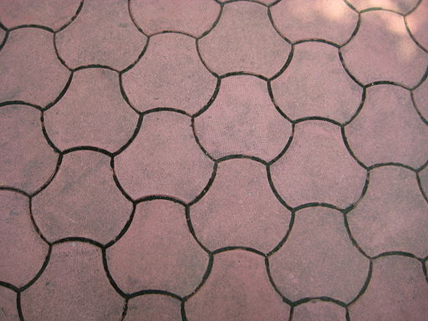

rotaļu kaste toybox
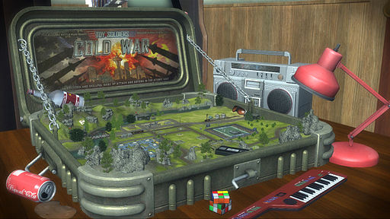

vāze vase
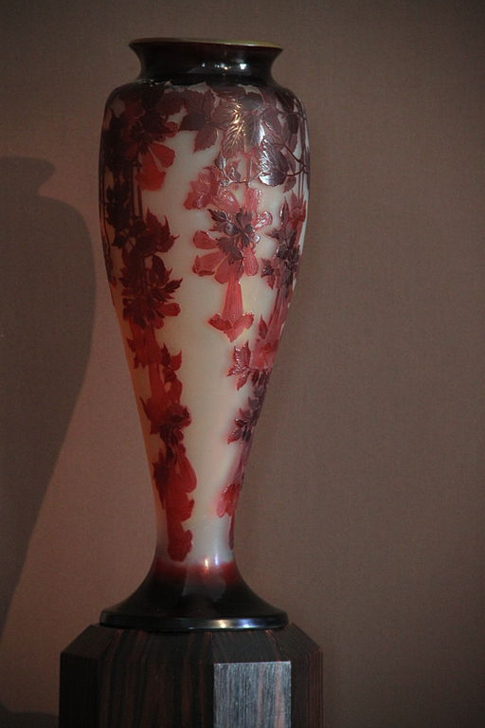
radio radio
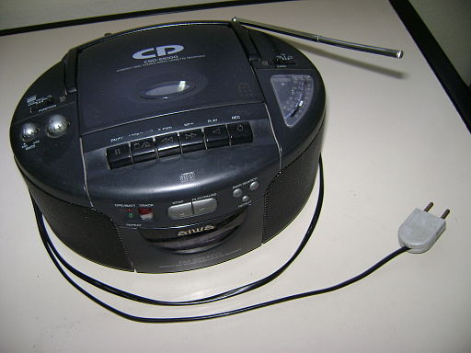

glezna painting


grāmatu plaukts bookshelf
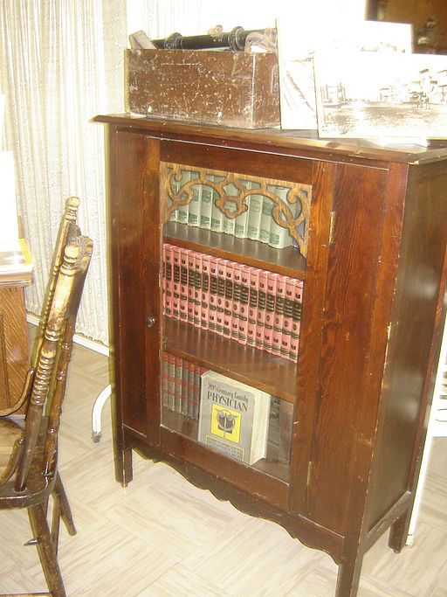

sekcija partition
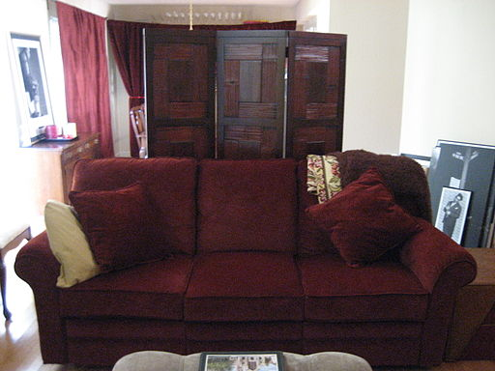

Now that you have placed all the items in their right places, how do we form simple statements to say where things are? To say ‘in’, ‘on’ or ‘at’ a place or thing in Latvian, we simply lengthen the last vowel (if there is one), or, if the word ends in the consonant –s, you replace the –s (usually) with ā.
If the Latvian for ‘The painting is in the living room’ is Glezna ir viesistabā, how do we say:
The mirror is in the bathroom.
The computer is on the table.
The table is in the kitchen.
The toybox is in the children’s bedroom.
The bathtub is in the bathroom.
The armchair is in the living room.
