Visiting the doctor

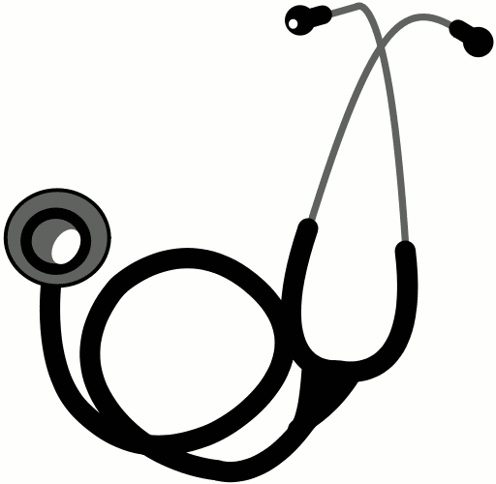

- 1. These are parts of the body in Japanese. Fill in the table below.

日本語 | ローマ字 | 英語 | 日本語 | ローマ字 | 英語
あたま | atama |  | かみ（ のけ） | kami (no ke) | hair
はな | hana |  | め |  | eye
は | ha | tooth/teeth | みみ |  | ear
のど | nodo |  | くち | kuchi | mouth
かた | kata | shoulder | うで |  | arm
あし | ashi |  | へそ |  | navel
ひざ | hiza | knee | ゆび |  | finger
おなか／はら | onaka/hara |  | て |  | hand
むね | mune |  | つめ | tsume | nail

2. Write the lyrics of the song “ Head, shoulders, knees & toe” in Japanese

- Head, shoulders, knees and toe
- Head, shoulders, knees and toe
- Eyes, ears, mouth and nose
- Head, shoulders, knees and toe

3. Translate these symptoms into Japanese.

A.) I have got a sore throat.
B.) I have got a headache.
C.) I have got a stomachache.
D.) My nose hurts.
E.) I have got a toothache.
F.) I have got a pain, here.

4. Match each advice from the doctor in Japanese with the English one.

A.) Yasunde kudasai. 1.) Please take some medicine.

B.) Kusuri o nonde kudasai. 2.) Please keep warm.

C.) Abura no sukunai mono o tabete kudasai. 3.) Please have a rest.

E.) Atatakaku shite kudasai. 4.) Please do not eat greasy food.

F.) Mizu o nonde kudasai. 5.) Please drink some water.

Answers:

A= B= C= D= E=

