

Interview with Natalia

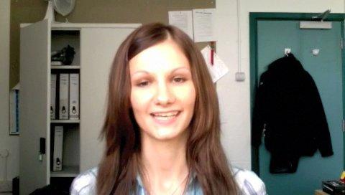

Watch the clip by opening the accompanying file (Natalia interview), then try and answer the following questions. Replay as often as necessary.

- Where is Natalia from?
- How long has she been in the UK?
- Does she have any brothers or sisters?
- Why has she come to the UK?
- What is she doing in the UK?
- What does she say about dancing?
- What does she say about football?
- Does she mention any other hobbies?

