London Quiz

- What is the name of London’s river?

- Who is the current Prime Minister?

- What street does the Prime Minister live in?

- What is the name of London’s largest park?

- What is the tall statue in Trafalgar Square called?

- Which park is in front of Buckingham Palace?

- What happens every day at 11am outside Buckingham Palace?

- Which sport is played at Twickenham?

- Which park is the home of London Zoo?

- Which area of London can you find the Houses of Parliament?

- What is Wimbledon famous for?

- What is Big Ben?

- Name two lines on the London Underground?

- Who is the mayor of London?

- What is the busiest shopping street in London?

- What would you find along Shaftsbury Avenue?

- Where is Harrods located?

- What happens every year on the Queen’s Official birthday in June?

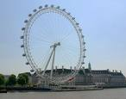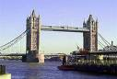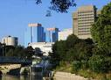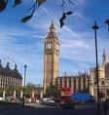

Useful websites: http://www.london.gov.uk/

http://www.bbc.co.uk/london/

