



Remember to include pictures of the food you choose in the menu.

Pictures of all the food from PowerPoint to be cut out (small ) and laminated for the students to be able to stick on to A3 to create a menu. They write the Urdu underneath each picture (in English script)

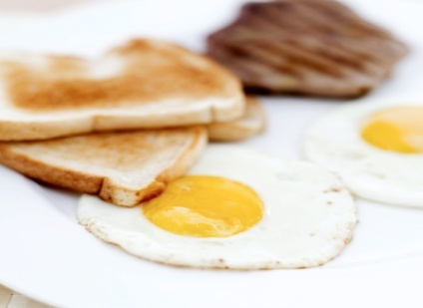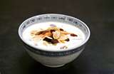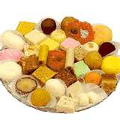

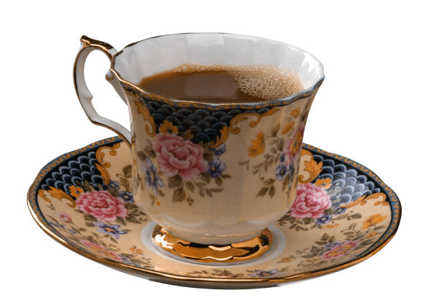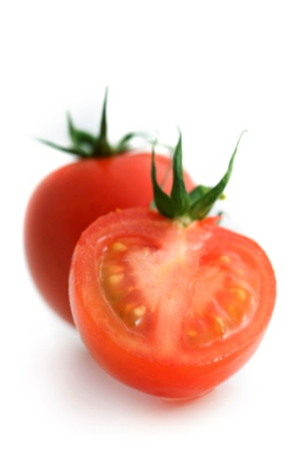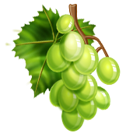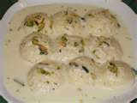C:\Documents and Settings\Nabila\Local Settings\Temporary Internet Files\Content.IE5\RL2L9DUQ\MCj04259320000[1].wmf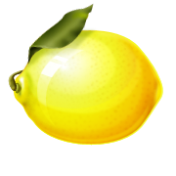

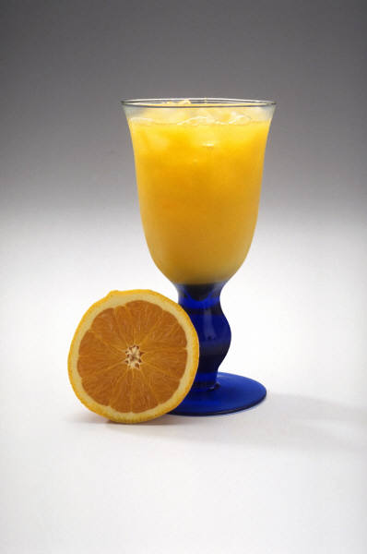C:\Documents and Settings\Nabila\Local Settings\Temporary Internet Files\Content.IE5\9ET6OUFA\MCFD00524_0000[1].wmfC:\Documents and Settings\Nabila\Local Settings\Temporary Internet Files\Content.IE5\0UYEI4NY\MCj02508400000[1].wmf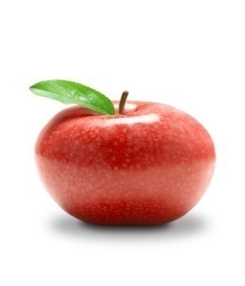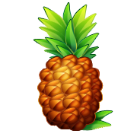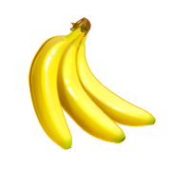

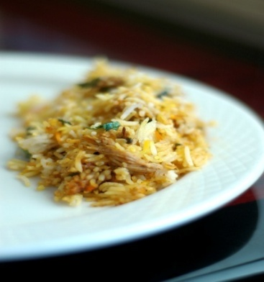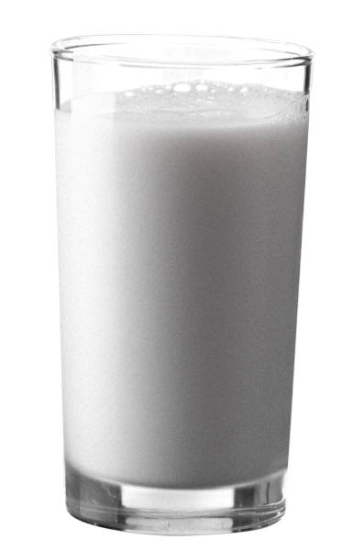

C:\Documents and Settings\Nabs\Local Settings\Temporary Internet Files\Content.IE5\PY6LJ1WG\MCj01124000000[1].wmf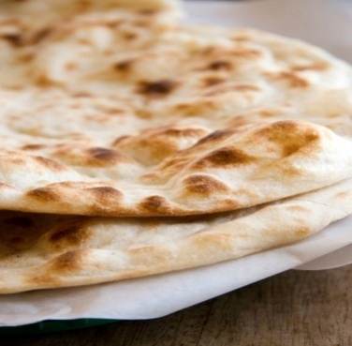

C:\Documents and Settings\Nabs\Local Settings\Temporary Internet Files\Content.IE5\D9NP69IA\MCFD00496_0000[1].wmf