Urdu – Parts of the Body

Name: …………………………………….. School: ……………………………………..

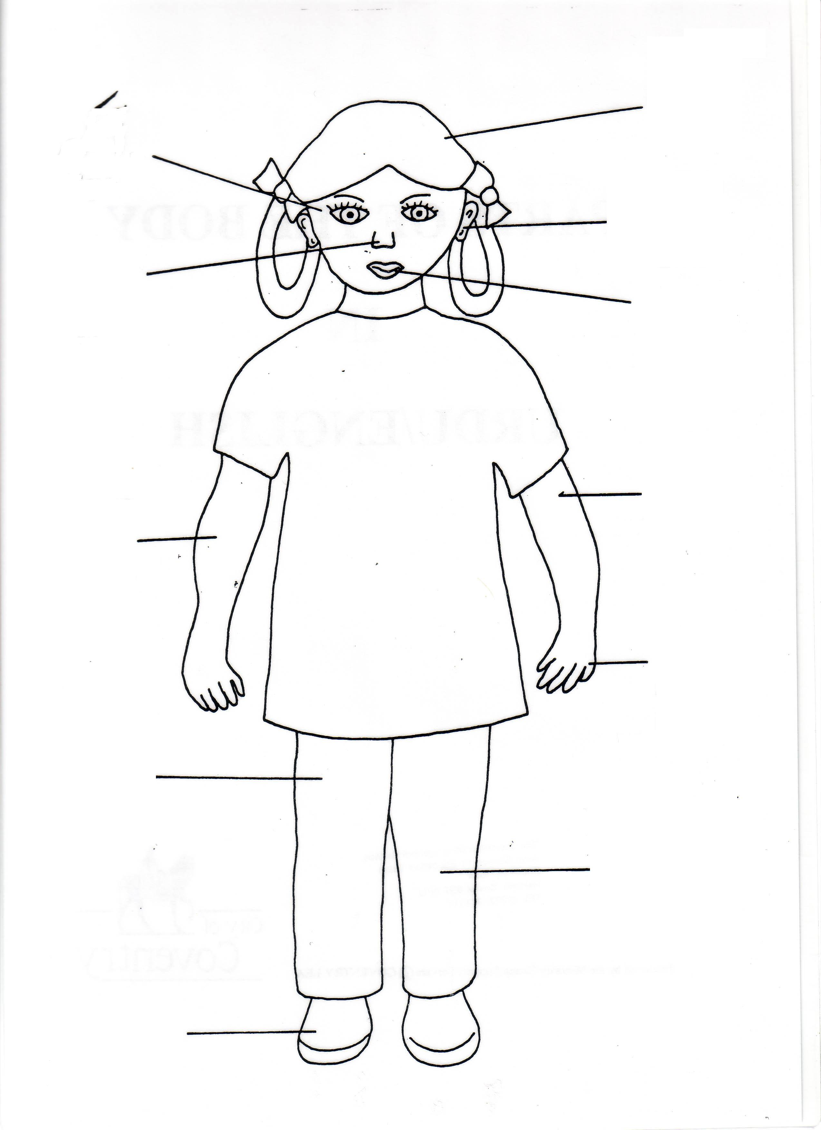
1) Choose the correct part of the body from the box and fill it on the person.

2) On the other side of your sheet, design a monster and label the body!

Words

ungli kaan haath paao
kohni gutna dant baal
aankh baazu taang naak

