Handout W3.2
Using images from the internet in your teaching
When creating teaching resources for use in class, it has become common to use the internet to find good, quality images. Searching on a site like ‘Google images,’ results in finding thousands of images to suit any context you wish.
And once you have found the image that you wish to use, it is a simple job to copy it into a Word document or other file, print it off and use it with your students. However, if you wish to publish your teaching resource on the LanguageBox or another open website, you may be in danger of breaking rules on copyright if you have included pictures/cartoons or work by other people.
Often, this does not present a problem if you have attributed the work of others correctly, e.g.
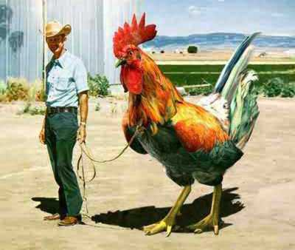
Photo courtesy of kikistrikeny.blogspot.com
There are lots of sites which provide copyright-free images. Here are some examples:
Getty images: http://www.gettyimages.co.uk/CreativeImages/RoyaltyFree?isource=gbr_chp_midUpperRight_RFImages
iStockphoto
http://www.istockphoto.com/index.php?view=full
Photobucket
http://photobucket.com/

You can also find such images on Google images and Flickr.com, but you have to search for them. This is how:
- go to Google images http://www.google.com/imghp
- type your search term (e.g. cat)

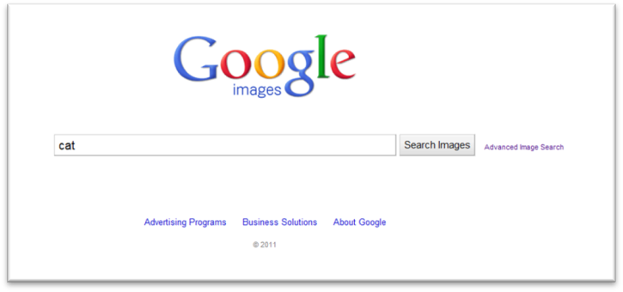
- click ‘advanced image search’ at the end of the main search box

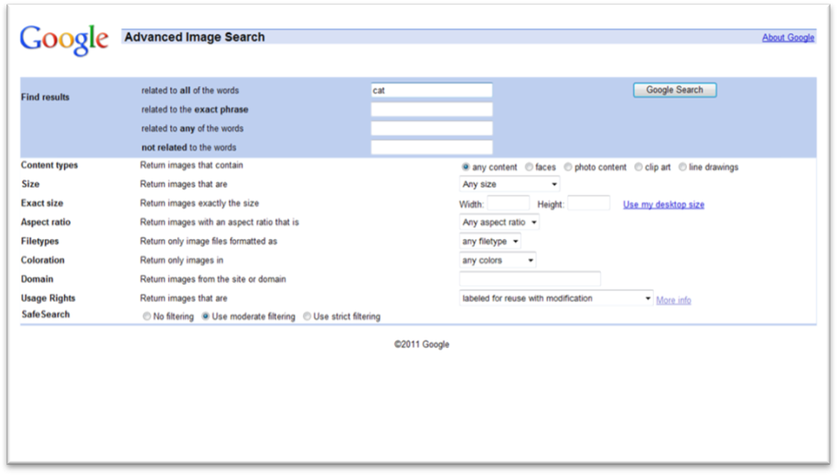
- Type your search term (‘cat’) in the top box and then scroll down to ‘usage rights’ at the bottom of the page. Click on the arrow on the right-hand end of the box and choose ‘Return images that are…labelled for reuse’ or ‘…labelled for reuse with modification’. Then click the ‘Google Search’ button at the top.

This will give you a range of images that are ok for you to use (but you should still always remember to attribute the author by saying ‘image courtesy of XXX’ on your material).
Example:
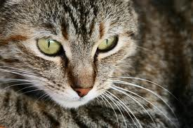
Image courtesy of si.smugmug.com

Modifying images that you find on the web
If you wish to alter an image that you find on the internet in any way (e.g. by altering the colours, adding writing to it etc), then you must ensure that you choose ‘images…labelled for reuse with modification’.
The cat picture above has been modified: it was saved, then opened in ‘Windows picture manager’, and the contrast, brightness and colours altered.

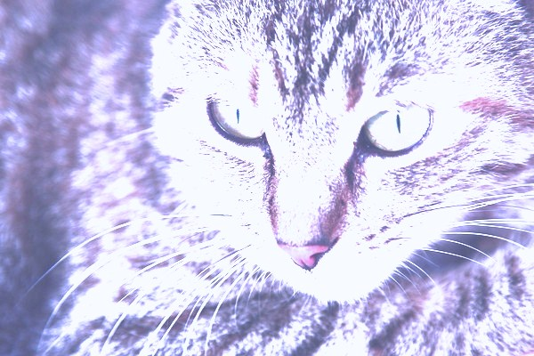
Image courtesy of si.smugmug.com

