Handout W1.2.1

How to create a style sheet, change fonts and insert tables

Styling
When you create handouts for your students to use in class, or for homework, it can be fun for you (and your students) to use different fonts, colours, simple images, tables and other features. Simple styling can be very effective by making a document look pretty, appealing and interesting. Such styling is possible within word-processing software, such as Microsoft Word. Using a particular style, font and colouring also makes your work look professional, and if you use a similar style for all of your documents, then it also become recognisable as your own personal work.
This document will give some basic advice on how to put some styling into a Microsoft Word 2010 document.

Fonts
There are a range of possible fonts available through Word and each has a different name, for example:
This is Times New Roman.
This is Bradley Hand ITC.
This is chiller.
This is Broadway.
This is curlz.
This is comic sans.
Some of these fonts are formal and professional-looking, others are informal and stylish. Choosing a good font can make your handouts look fun and interesting to students.
To start writing in a particular font, firstly you must open a new blank Word document. The menu bar at the top of the page will tell you which font is currently set. In the screenshot below, you can see that the font ‘Calibri,’ at point size 12.

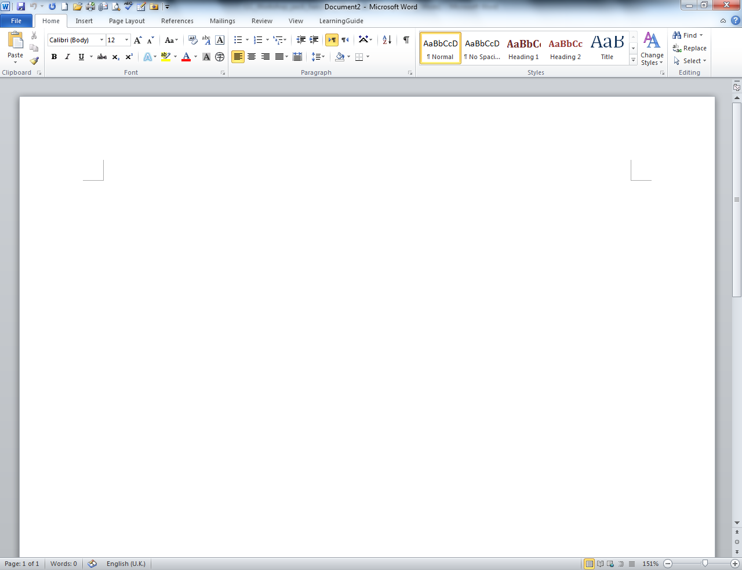
If you were to start typing on this blank page, your words would appear in the font ‘Calibri.’
However, you may wish to use a different font. To change the font, click on the small arrow next to where the font is named.

A full list of all the fonts available to you will appear. You can use the scroll bar to look through all of the fonts and decide which you want to use.
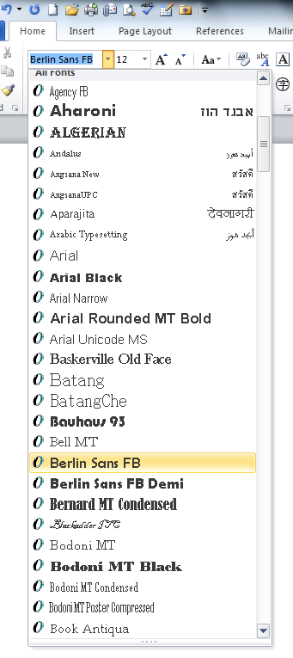
Click on the font that you wish to use. You will see that it will appear as the named font in the box on the top left of the menu bar, in this case, replacing ‘Calibri.’
You can then begin typing.
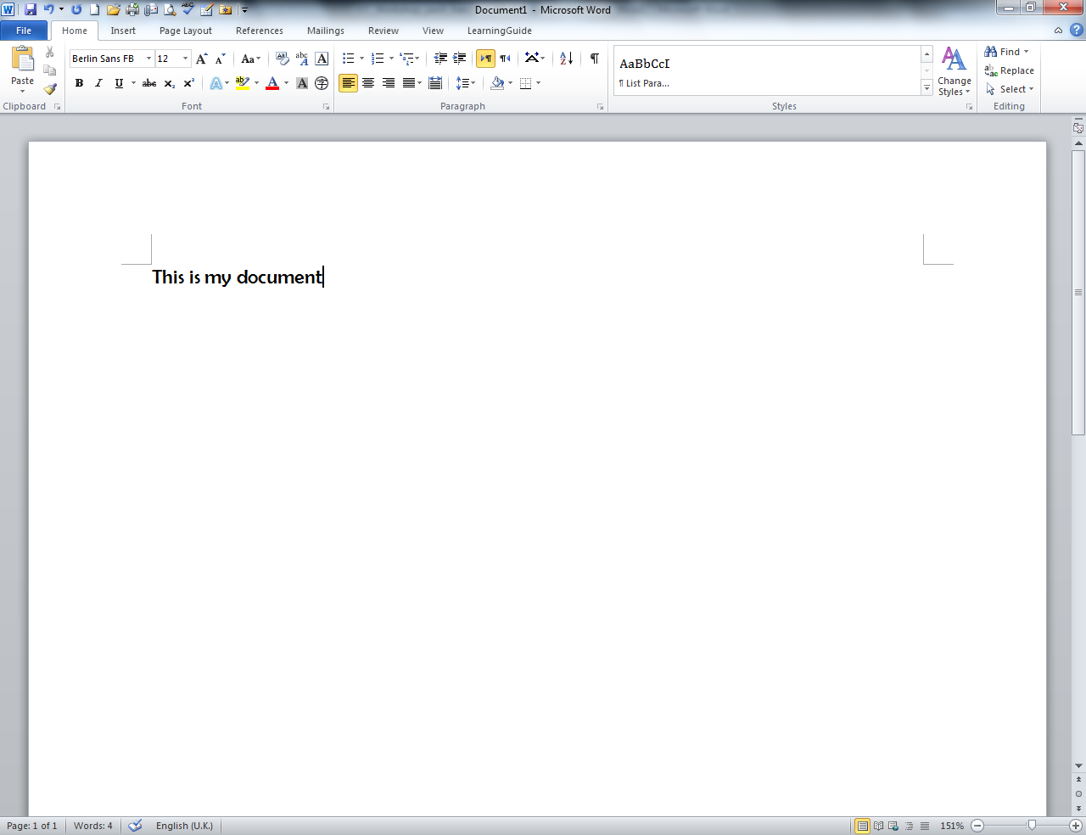

You can change the size of the text very easily. Look at the top left of the menu bar. Next to the box telling you the font currently in use, is a number ‘12’. This indicates that the font is point size 12. Change this by clicking on the arrow next to ’12.’
A list of font sizes will appear. Choose the one you want, or if the number you want is not in the list, just type it in the box. In this case, I’ve selected ‘36’.
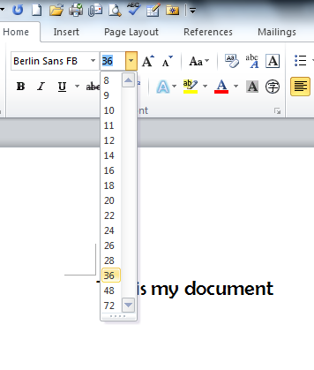
Everything I write will now have size ‘36’ until I change it again.
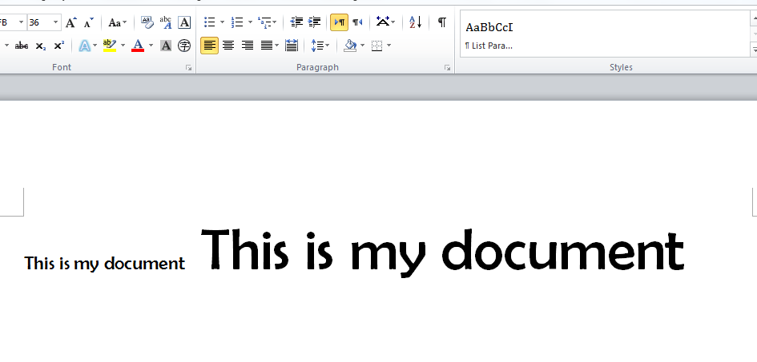
This enables you to create posters, newspaper-style headings and other headings which make parts of your text stand out.

Changing fonts/sizes of existing text
You may wish to change the font or size of text after you have written it.
To do this, highlight the text that you wish to change by rolling the mouse over it and holding left button down. Then click on the arrow next to the font box and choose the font that you wish to use. Do the same if you wish to change the size of existing text.
Remember to save your changes regularly as you are working!

Using simple images (clipart)
It is very easy to put simple images into a Word document, using ‘clipart.’ Clipart pictures are a bank of drawings, photos, videos and audio recordings held in Word, which you can use to enhance your document, for example here are two clipart pictures of a dragon:

If you wish to use clipart in your document, firstly click your mouse in the position that you wish your picture to be. Then click on the ‘Insert’ tab on your menu bar.
A new menu list will appear across the top of your screen. Click on ‘clipart’.
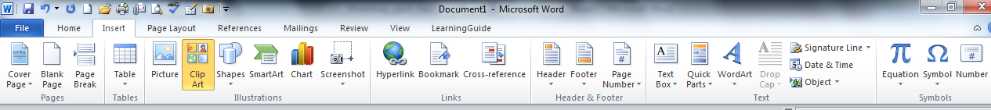

A new field will open on the right-hand side of your screen. At the top of this field is a search box. Type in the search term for the image that you wish to put in your document and click ‘go.’ In this case, I’ve typed ‘cat.’ A long list of the available ‘cat’ images has appeared. Use the scroll bar at the side to see all of the possible images.
To choose one, just click on it.
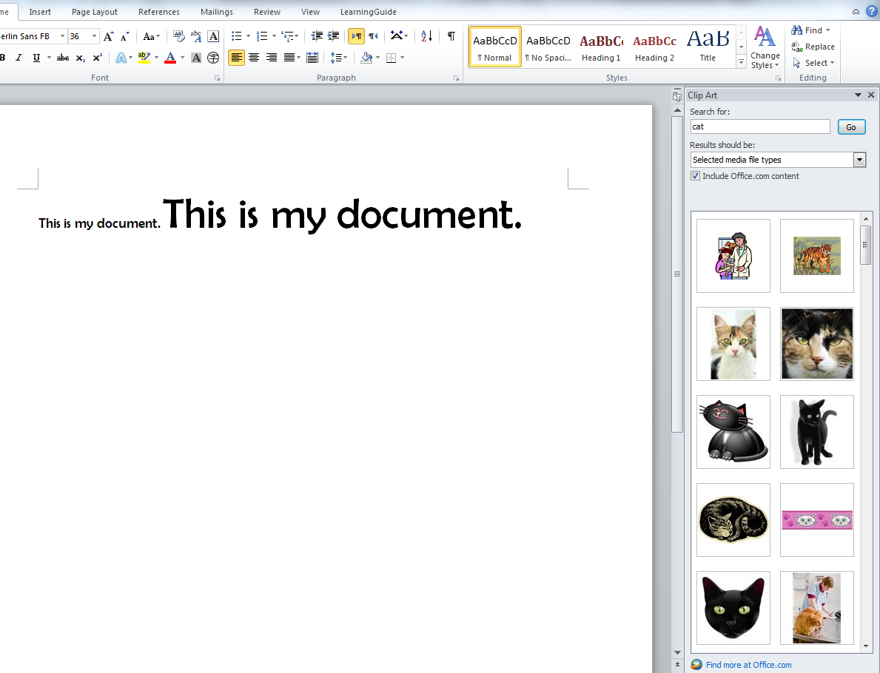

It will appear in your document (see below).
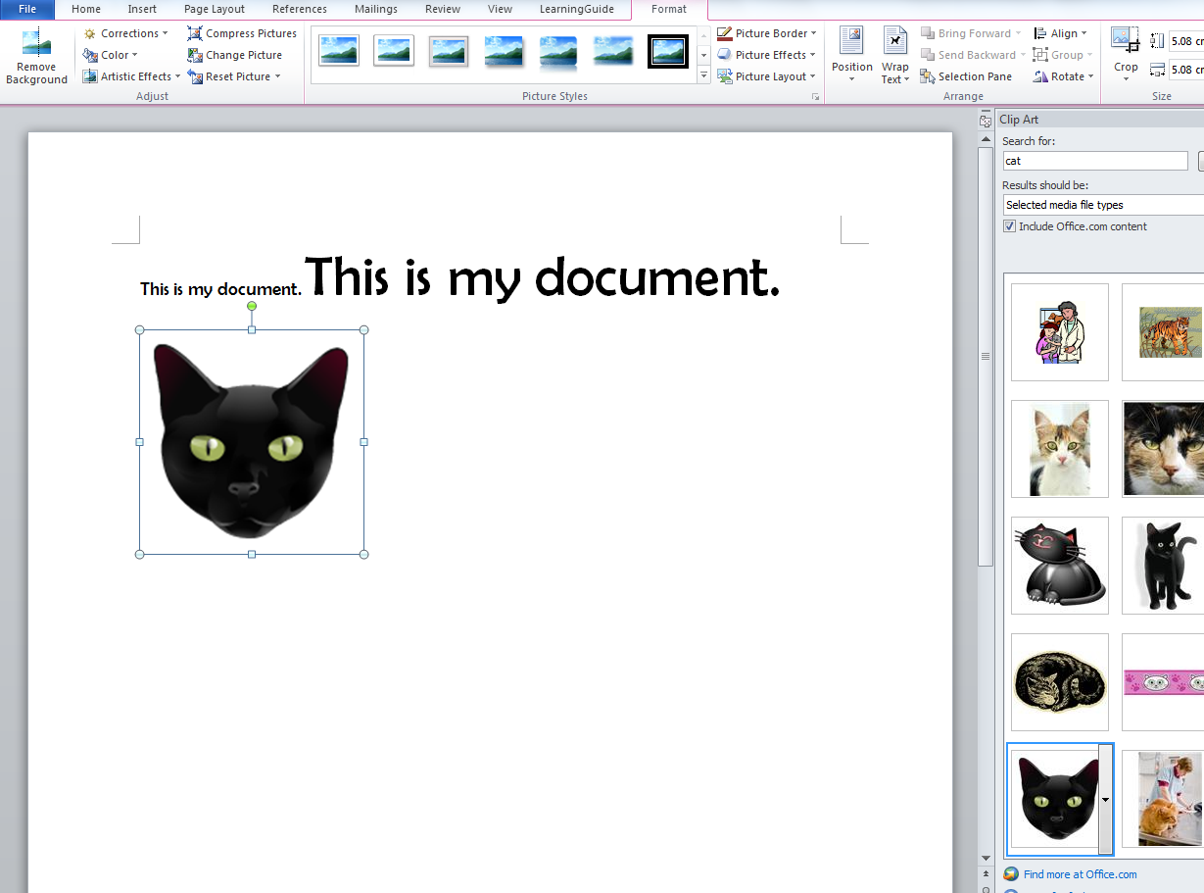

You can alter the size of the image by clicking on one of its corners and dragging it to the size that you wish. There are other ways of formatting the image too, for example changing colours, background, rotation etc. You can experiment with these features using the picture toolbar which appears as a tab in the top menu bar of the screen when you click on the image.

Putting tables in your document
It is often useful to present information in a table. This can be done easily in Word by inserting a table in your document. Tables are useful when you are creating simple activities for students to do in class, or at home.
If you wish to use a table in your document, firstly click your mouse in the position that you wish your table to be. Then click on the ‘Insert’ tab on your menu bar.
Click on ‘table’. A box will appear. Roll your mouse over the number of cells that you wish your table to have (don’t worry if you are not sure, you can change this later). For example, I have selected a 3x3 table below.
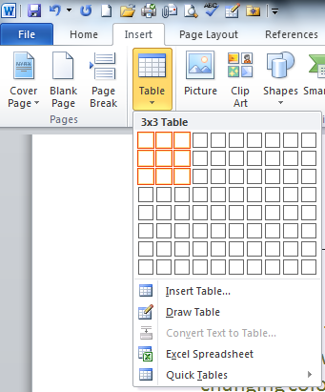
The table will appear in your document, like this.

Then you can write information in the cells, by clicking in each one and starting to type, for example:
 | Green | Blue
Sky
Grass

You can change the size of each column by running your mouse over each line. When the cursor changes to two small lines + small arrows, hold the left mouse button down and move the column to the size that you wish. Be careful and slow when you do this, as it is fiddly to do!
If you wish to add an extra row, click in the final cell, and press the ‘tab’ button on your keyboard.
If you wish to add extra columns or rows in the middle of the table, click with your right mouse button in one of the cells either above or below where you wish to put the extra section. Choose ‘insert’ and select the appropriate choice. You do the same thing if you wish to delete rows/columns.
You can write text into the cells or you can insert images or other media files. There are also lots of ways of formatting tables in general, if you right click on the top left corner of your table.
Remember to save your work as you go along, and if something goes wrong, you can always click on the ‘undo’ button to undo your last action.
Or in the worst case, delete the table and start again!

