Handout W4.1

Using Hot Potatoes: quizzes and gap-fills (Jcloze)

Hot Potatoes is freeware which you can download and use in your classes to create exercises.
You can find it at: http://hotpot.uvic.ca/
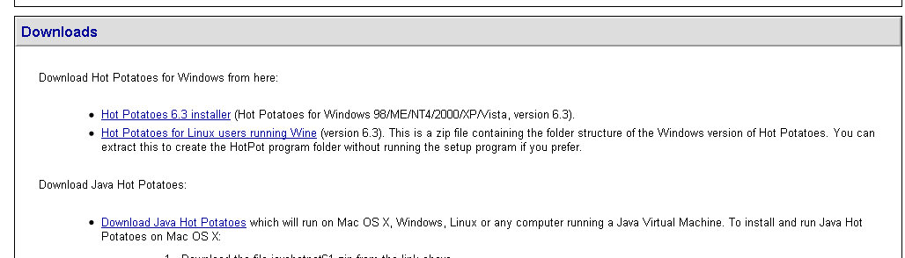
Click the ‘Hot Potatoes 6.3 installer’ and choose ‘save file’ to save it to your computer.
NOTE: When you first start up Hot Potatoes, it may ask you for your user name. This name is stored on your computer, and not sent to anyone; it will be inserted into your exercises to identify you as the author. You must provide a user name before you can use all the features of Hot Potatoes.
When you download HP and run the program, you will see this screen:
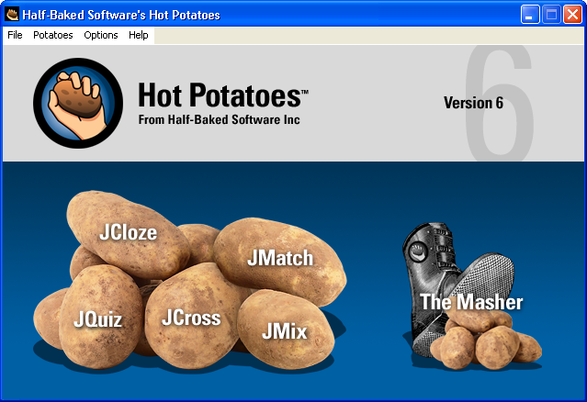

This page is the ‘start’ page and allows you to create gap-fill (cloze tests); matching exercises; quizzes; crosswords and mixing exercises (e.g. mixed sentences). The masher enables you to create a basic web page to link several different activities together. You click on a potato to start making an activity.
NOTE: Before you start making any activity, you should create a folder somewhere on your computer in which you are going to save your Hot Potatoes file. You should put into this folder any pictures, audio files or videos that you intend to use in the activity.

Creating quizzes in Hot Potatoes
The JQuiz function allows you to set quizzes and ask questions. These are the possible question types: multiple choice answers, short answer (students have to write a short response), hybrid (which allows you to set an open question which transforms to a multiple choice after several attempts) or multi-select (where students can check multiple correct answers).
The instructions below describe how to create a basic multiple choice quiz.
Click on the JQuiz potato to start making an activity.
This is the screen for a JQuiz activity:
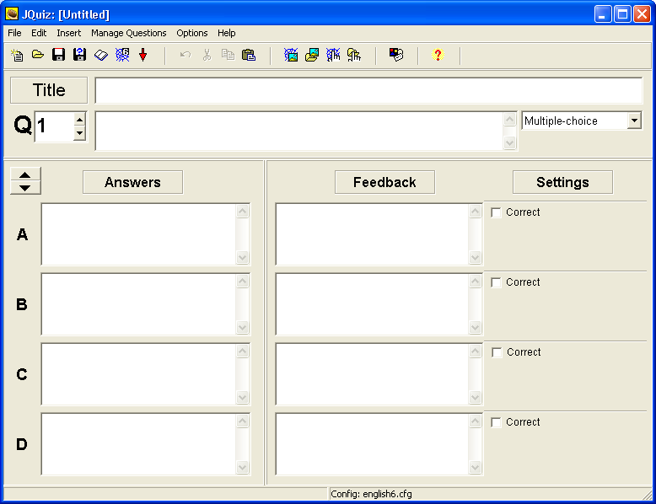

The box in the top right allows you to set the type of question that you wish students to complete. Set the answer to ‘multiple choice’.
Write in the title of the activity, e.g. Words to describe the weather.
Write in your first question next to Q1. You may insert a picture here if you wish (see below for instructions how to do this).
Then write in each word, sentence or phrase that you wish the students to choose from. Ensure that only one answer is the correct one, and tick the box in the ‘settings’ column to show that it is the correct one.
Write in your feedback. Include feedback for correct and incorrect choices – and give students a clue to help them select the correct answer.
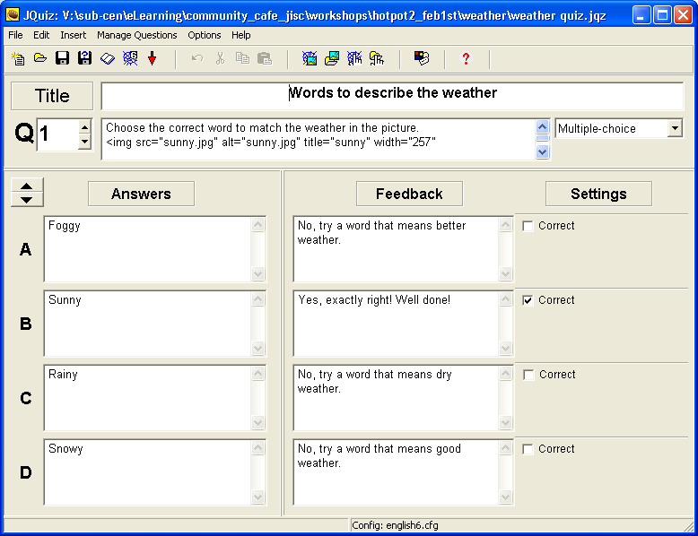

If you wish to put in more than 4 options, you can. You do this by selecting the arrow keys next to the ‘answers’ column.

If you wish to change the colours, fonts etc. of your activities, go to the configuration screen – circled below.
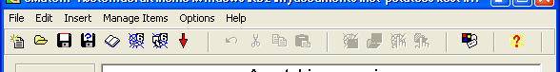

You will see this screen:
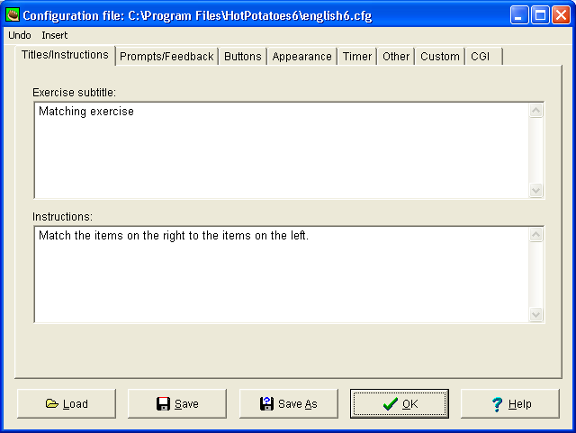
- Click on ‘titles/instructions’ to amend/edit these fields. Think about the instructions that you will give students who wish to do the activity – do you need to explain what you want them to do more clearly?
- Click on ‘prompts/feedback’ to amend/edit the feedback given for correct/incorrect answers.
- Click on ‘buttons’ to amend the wording on buttons or to remove them. (It is a good idea to untick the ‘index’ and ‘next page’ buttons).
- Click on ‘appearance’ to change colours, backgrounds and fonts.
- Click on ‘timer’ to set a time to the exercise.
The other buttons are for more advanced functions.
Remember that when you make any changes, you must click ‘save’ at the bottom of the configuration screen so that the system remembers them. When you have finished making changes, click ‘ok.’

If you wish to add more questions, then click on the ‘up’ arrow next to the question. This will give you a blank sheet to write the next question.

When you have finished writing questions/editing your activity, make sure you save everything that you have done by choosing ‘save as’ from the file menu, or clicking on ‘disk’ icon (the blue one circled; the red disk is ‘save’ and should be used after the first time you have saved your file).
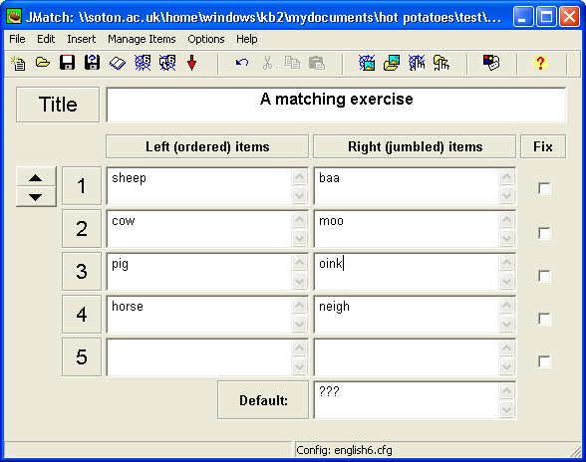

To make the activity into a web page which students can use, you need to export the Hot Potato file. Click the button which looks like a spider’s web, and has a little ‘6’ on it.

A box will open asking you to save the file. Save it in the same place as you have saved your Hot Pot file. You may give it the same name if you wish, or something different.
Once you have saved the file, a box will open asking if you wish to ‘view the exercise in your browser’. If you click on this button, you can view the activity which your students will see and do. If you don’t wish to look at it, just close this box.

***Very Important****:
When you use Hot Potatoes, you are creating two files: one is an editable Hot Potato file and the other is a web page. Students will use the web page. If you wish to make any changes to your activity, you must do this on the Hot Potato file, then save and republish the student (html) file. You cannot make changes to the student (html web page) file directly.

Making a gap-fill exercise
On the Hot Potatoes main screen click on the ‘Jcloze’ potato.
This is the screen for creating a gap-fill (JCloze) activity.
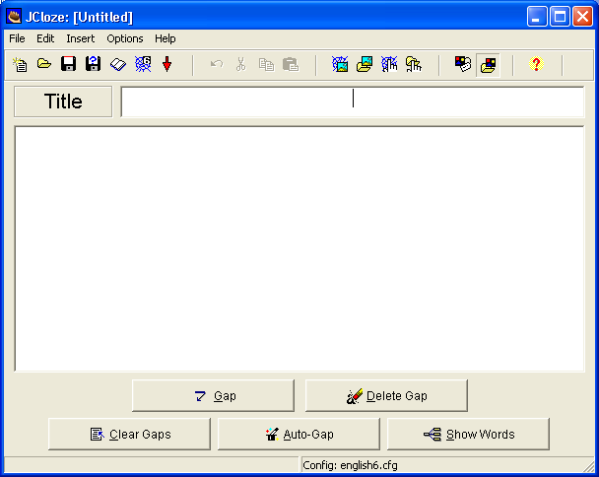

To make a gapfill exercise, give your activity a title and start writing your text in the big box.
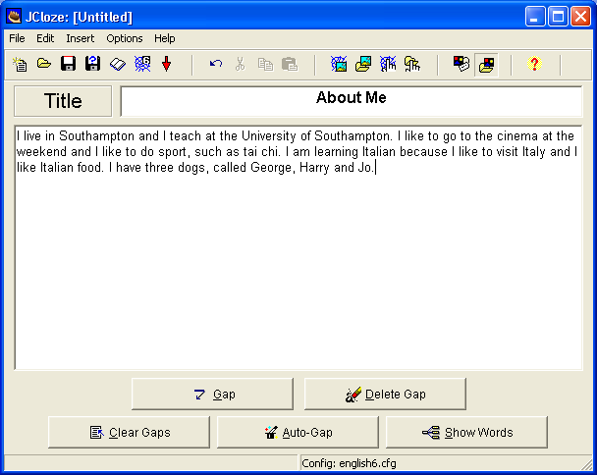
When you want to create the gaps in the text, highlight the word you want to gap using your mouse, then click ‘gap’. Another box will open. In this box, you have the opportunity to write a clue for the student, and give alternative correct answers. Click ‘ok’ when you have completed the areas you wish to.
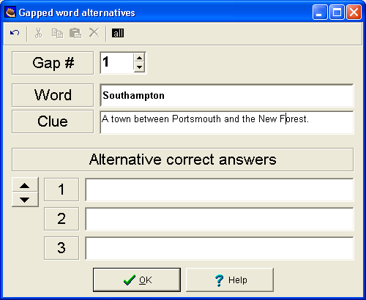

You will notice that the box disappears and that the word is now highlighted in red.
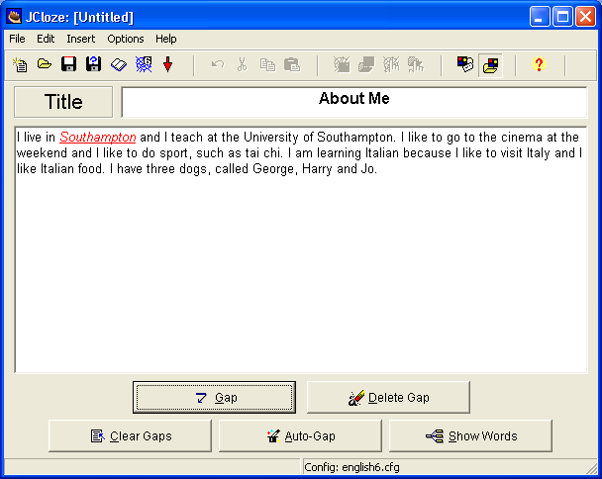

Continue writing in gaps as required. If you click ‘auto-gap’, then the system will automatically put in spaces for you.
Remember to save your file when you have finished, configure colours if required and then save as a web page.

Other features of Hot Potatoes
You can also insert pictures into your activities. These pictures may be on your hard drive or from a URL on the web. First, click on your activity with your mouse to show where you want the picture to go. Then use the buttons circled on the menu bar to insert a picture.

When you click on the button to find pictures on your hard drive, a window like this will open:
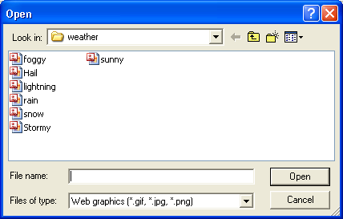
The computer will look first in the folder where you have saved your Hot Potato file, so it is best to have any images that you want to use already saved in there. Choose the picture and click ‘open’. Another window will open showing the image at the top.
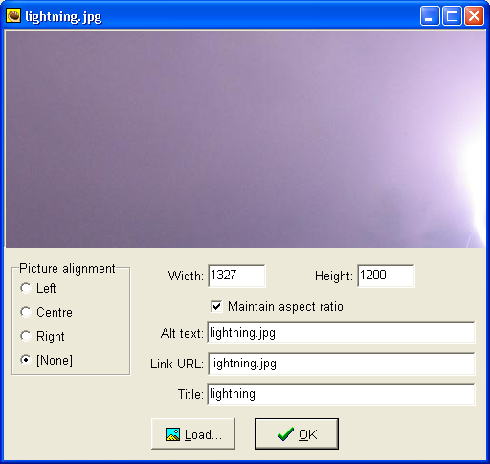
Note that this image is very large, and you will need to resize it. You can do this by changing the width and height, so for example, if you type ‘200’ in the width area, the image will resize to small enough for your Hot Potato activity (and the height ratio will alter automatically).

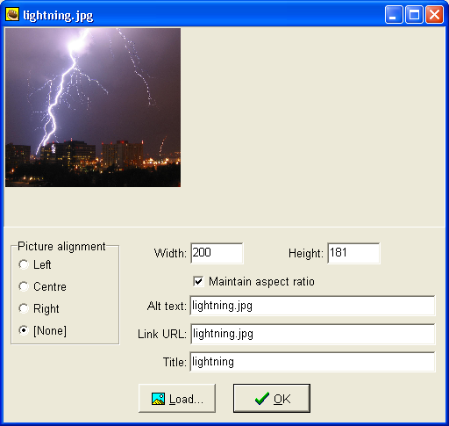
Press ‘ok’ and remember to save any changes on your main Hot Potato file.
You should make sure that you only use images that you have permission to use. These may be your own photos or photos taken from the internet. You can find copyright-free images on the internet at these sites:
Getty images: http://www.gettyimages.co.uk/CreativeImages/RoyaltyFree?isource=gbr_chp_midUpperRight_RFImages
iStockphoto
http://www.istockphoto.com/index.php?view=full
You can also find images which can be republished and adapted by looking on Google images and Flickr.com, but you have to search for them. This is how:
- go to Google images
- type your search term (e.g. cat)
- click advanced search
- scroll down to the bottom of the page and choose ‘Return images that are…labelled for reuse’
This will give you a range of images that are ok for you to use (but you should always remember to attribute the author by saying ‘image courtesy of XXX’ on your material).
Example:
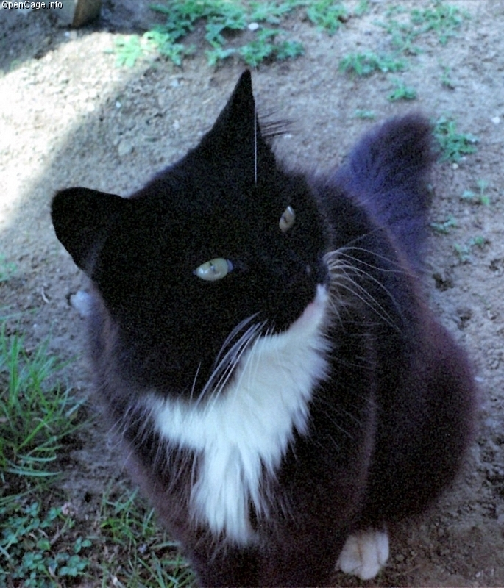
Image courtesy of opencage.info

An important note on saving and publishing Hot Potato files
When you use Hot Potatoes to create an activity, you are creating a web page. Web pages can be simple, but mostly, they are a complicated mixture of different files all linked together (images, audio files, video files, etc). This means that when you create your Hot Potato activity, you may have lots of different files which need to stay together for the whole thing to work properly.
Look at the example folder below:
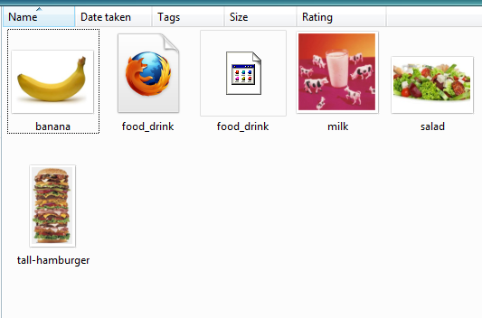
This is a Hot Potato quiz and it includes 4 images (a banana, a hamburger, a salad and some milk). The folder in which I have collected all of these files is called ‘food’ and it includes: the images, the Hot Potato file, and a web page (shown as a Mozilla Firefox page). All of these files need to stay together in order for the following activity to work:
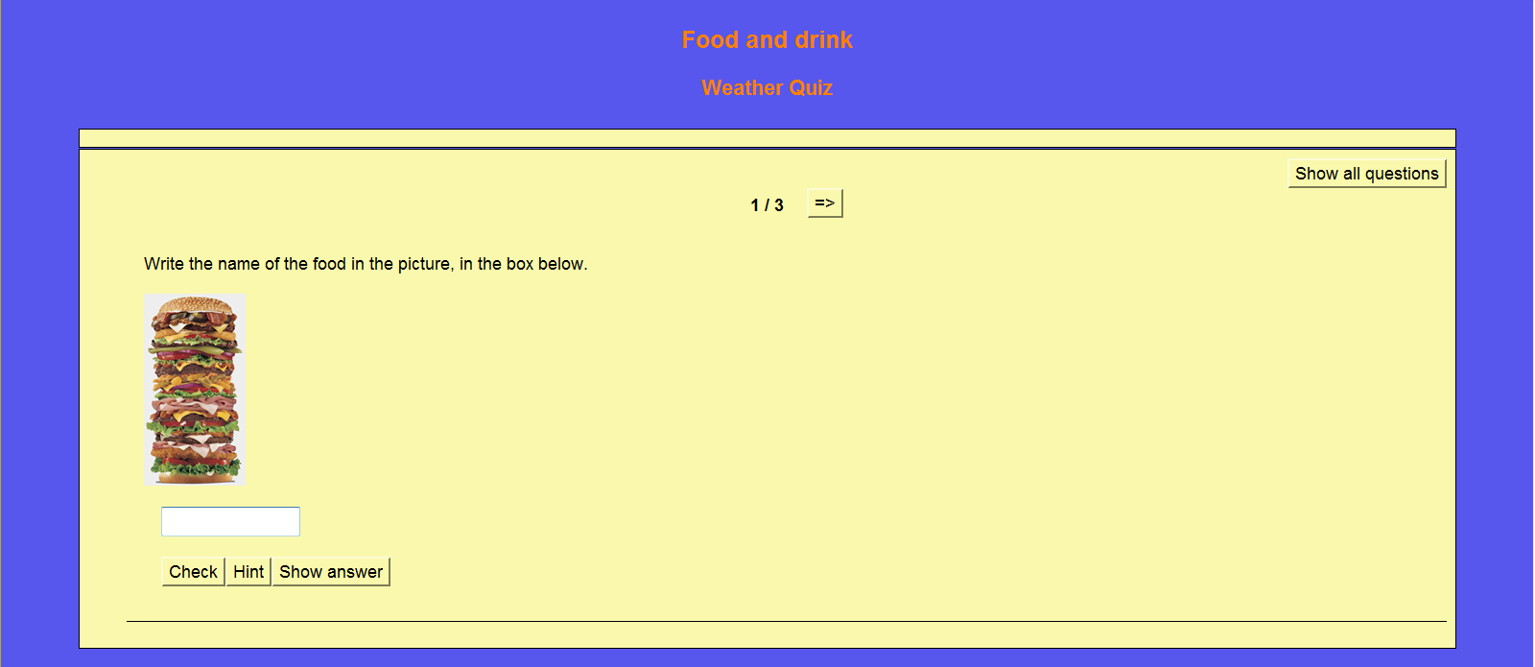

If you move one of the files, not everything in your web page will work. So for example, if I remove the picture of the hamburger from my folder, as below:
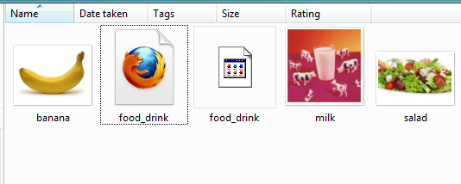

Then the activity would look like this:
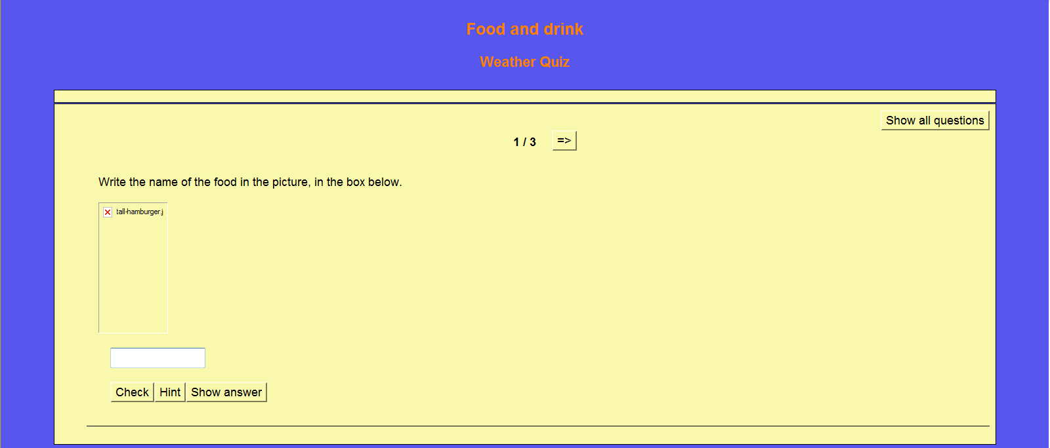
You can see that the picture does not show in the activity.
This means that it is very important to keep all of the files related to your Hot Potato activity in one folder. It also means that if you want to send your activity to someone else by email, or wish to put your activity on the web, or in a VLE, you need to send all of the files together. The best way to do this is by creating a zip file.

Creating a zip file
To create a zip file:
- right click on your folder
- choose ‘send to’
- choose ‘compressed (zipped) file’
This will compress your files and put them into a zipped file next to your original folder. The zipped folder will have the same name as the original folder. You can tell it is zipped because it has a little zip on it! (see below)
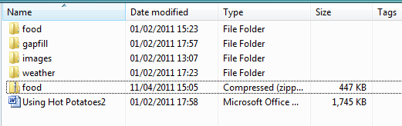
A zipped file is compressed and can be sent via email or added to a website.
Remember: if you wish to open a zipped file and look at the contents, you must extract it first. You do this by right clicking on the zipped folder and choosing ‘extract all’.

