JISC Developing Community Content Programme: strand II
The Community Café Project: final report

“The project has opened a new door for community language teachers…” Dr Sarwar Jamil, Southampton City Council

Authors: Kate Borthwick, Alison DickensContact:
Kate Borthwick, kb2@soton.ac.uk
Project Manager,
Subject Centre for Languages, Linguistics and Area Studies,
University of Southampton,
65a/3011, Avenue Campus
Southampton
SO17 1BJ
Community Cafe Project : Technology with tea and cake
The Community Café project was a collaboration between the Subject Centre for Languages, Linguistics and Area Studies (LLAS) at the University of Southampton; Southampton City Council and the COLT project at Manchester Metropolitan University. The aim of the project was to work together to co-create a community collection of online language and cultural materials for use by those engaged in the community-based teaching and learning of languages within the local Southampton area and beyond. The project combined informal ‘café’ style meetings for the sharing of pedagogic knowledge in a social environment and networking, with workshops on various aspects of using technology in teaching. All materials created under the project have been released on an open access website, called the LanguageBox, which also acts as an online space for collaboration, sharing and networking amongst language teachers across all sectors in education within the UK. The project has been extremely enjoyable and successful in exciting the enthusiasm of a particular community group about creating effective teaching resources, sharing ideas with others and publishing teaching resources openly online: in the words of Dr. Sarwar Jamil, the Community Languages Manager at Southampton City Council: “The project has opened a new door for community language teachers.”
What are ‘community languages?’
For this project ‘community languages’ were defined as “…languages spoken by members of minority groups or communities within a majority language context” (Cilt). The Southampton area, for example, is home to a wide range of community languages, including Gujarati, Bengali, Chinese, Afghan Farsi, Hindi, Malay, Malayalam, Persian, Punjabi, Polish and Urdu. These languages are often taught and learnt in informal, community-based situations (e.g. in the home, in supplementary schools) rather than within the mainstream education system. In recent years qualifications in many community languages have become available, e.g. GCSEs or assessment through the Asset Languages scheme, for example: in Hampshire, 17 languages are taught by more than 150 teachers to GCSE level. The acquisition of such skills and qualifications has economic and social benefits, for the individuals, the communities and the UK as a whole.
However, teachers of such languages are frequently volunteers and either receive no remuneration or are paid a low hourly rate by Local Authorities. Southampton City Council, for example, apportions a small amount of funding towards maintaining a network of community-based language teachers, giving occasional basic training and maintaining a modest collection of resources.
Historically, community languages have been undervalued by society in favour of English and other modern European languages which are often seen to have more prestige or usefulness (for example, in gaining access to university or opening up job opportunities in the UK and abroad). This is despite the fact that research indicates that plurilingualism is of benefit to the individual and to wider society: “for the individual plurilingualism is known to produce cognitive advantage” (McPake and Sachdev, 2008), to improve performance in a variety of educational tasks including the acquisition of literacy; other languages, and “to delay the effects of aging on the brain” (Bialystock et al, in McPake and Sachdev, 2008). For society, there are clear economic advantages if adults can use several different languages in commercial life and the globalised nature of commerce in the 21st Century means that knowing other languages of any kind (alongside English) is an extremely useful ability. Plurilingualism has social benefits too, in broadening understanding of other cultures and peoples within the UK context, and multilingual individuals “have the potential to...constitute a valuable resource for wider society” (McPake and Sachdev, 2008).
What problem did we aim to address?
The project addressed a particular problem: the scarcity of up-to-date, online resources for the teaching of community languages.
It is extremely challenging to be a community-based language teacher. Most teach out of love for their language and culture and have no formal teacher training. They often work full-time in professions unrelated to teaching and have family commitments, so they have very little time for preparation, resource development and professional development. Their situation is made more difficult by the fact that there is often very little appropriate language learning material available for the languages they teach; what is available is outdated, and their student groups are frequently diverse in age and ability, and so they are constantly required to create their own materials. There are a great many community languages teachers working across the UK, but few mechanisms for them to share their work, support each other or work collaboratively. The project team felt that this was a group that would clearly benefit from engagement with the open content movement which encourages the creation and sharing of teaching resources in open access repositories and the use of online networks for sharing good practice. The benefits of the open content movement are already well-known in the Higher Education sector in the UK and are currently being explored and exploited with enthusiasm in all mainstream educational sectors. We felt that the OER emphasis on sharing would directly support teachers in discovering, adapting and creating their own materials.
What did we aim to do?
Our primary aim was to use expertise and tools developed at the University of Southampton to collect and co-create digital resources for community languages. However, we had other aims too:
- to build a self-managed community-based group to support community language speakers engaged in teaching and learning the range of community languages available locally
- to improve the pedagogy of existing materials through peer review and discussion, and encourage general reflective practice
- to provide bespoke and incremental training in using, creating, publishing and sharing digital content
- to contribute to the enhancement of the profile and provision of community language learning through adding resources to an online repository hosting a wide range of language resources used in all UK education sectors
- to open up connections and strengthen existing relationships between academic departments and the local community (both in Southampton and in other geographical locations taking part in the project)
How did we do it?
Communications
The first task facing the Community Café project team was to bring together speakers of a variety of community languages to hear about the project and agree to take part. We decided to make use of the existing Community Languages support network, coordinated by Dr Sarwar Jamil, at Southampton City Council, to introduce teachers to the project. Dr Jamil is personally acquainted with all of the teachers, and uses every means available to make contact with them (e. g. email, fax, telephone, letter). This range of communication methods was essential as each teacher had their own preferences in how they dealt with the outside world, and so although the project team set up a JISCmail list for project communications, there were individuals who preferred to be contacted by other means, and Dr Jamil could take charge of this and ensure that all teachers were aware of project activities at all times. The project team also set up a blog early in the project timeline – not only to communicate aims to the outside world, but to record activities in an informal way for the group.
Cafe meetings
The project team set up an early meeting to outline project aims, introduce the ‘cafe-style’ sessions and canvas for participants. We used a model of community engagement developed by LLAS as part of an EU-funded project, ‘The Language Café.’ That project responded to a demand for informal and socially-situated language learning and created over 20 Language Cafés across Europe. The model has proved itself to be sustainable and new Language Cafes continue to spring up with regularity. The benefit of the Language Cafe model is in its informal, user-centred nature, something that we felt would be particularly important for this project as participants would be likely to lack confidence in using or sharing digital resources; be reluctant to share resources they may feel are not suitably ‘professional’, or simply reticent about sharing their existing practice with others outside of their language groups. The intention was that the Café meetings would provide a forum for ‘offline’ discussion and would supplement a series of workshops offering training in the use of technology for resource creation and sharing.
The first meeting/cafe session was held at a local school in Southampton. This location was the usual venue for meetings of the Community Languages Network and it became our regular Cafe location. Meetings were necessarily held ‘out-of-hours’ because this is the only time that the teachers were available. We were able to use the governors’ meeting room, which felt rather more professional than using a classroom, and made the teachers feel more like equal participants than students – an important point to emphasise, since community-based language teachers are not often given access to good equipment and resources. Coffee, tea and other refreshments were also possible in this particular room. It was not, in fact, our initial intention to use the school for meetings: we had hoped to negotiate a local, public venue for Cafe sessions, such as a cafe or the library, but participants were clear in their preference for a familiar location which was quiet and had ample parking.
The first session was designed with the idea of getting teachers to join the project, but also to encourage them to have input into the shape of future meetings. We felt that this was essential to the success and sustainability of the project, because if participants had input into the programme of activities, they would feel a sense of ownership in the project and activities would be directly relevant to them and their teaching. Cafe meetings were held every month, on a Tuesday, 7-9pm, and had a loose structure involving lots of discussion and idea/practice sharing. Meetings were lead by members of the project team, who usually introduced a theme (e.g. ‘using authentic materials in teaching’) and encouraged participants to mix with new acquaintances cross-language groupings. Meetings always featured lots of tea/coffee drinking and cake consumption (carrot cake being a favourite). The themes covered in cafe sessions were chosen to complement the training workshops which ran in parallel, so for example, prior to a workshop on creating podcasts, the cafe session was used to talk through ideas about how to use audio recordings in class and the kinds of elements to consider when creating a podcast. This meant that participants were prepared and ready for the workshops, which all had a very practical focus. We also made an early decision to encourage the teachers to focus the resources that they would create and share around a particular topic, e.g. holidays, festivals etc. Our reasoning for this was that over the succession of workshops, they would build a portfolio of varied but related and coherent digital resources, which could form the core of a shared collection.
Workshops
The Community cafe team ran 6 evening workshops in the use of technology in language teaching over the course of the project. These workshops were held in a computing classroom at the University of Southampton and were facilitated either by members of LLAS or by specifically commissioned trainers. Topics were negotiated at the outset of the project with the participants and were on these areas: using and sharing material on the LanguageBox; creating podcasts; using powerpoint for language teaching; creating online activities using Hot Potatoes – part 1; creating online activities using Hot Potatoes – part 2, and tips for teaching diverse groups. There were also several informal sessions during which participants worked on material of their choice.
All workshops were highly practical offering all participants the opportunity for hands-on experience with software. This ensured that each teacher could work on a resource individually and build up her/his digital portfolio. The workshops were structured around an achievable task: each participant was able to complete a digital item by the end of the workshop – and this encouraged a sense of achievement and empowerment in the group.
The project also offered a number of small project grants to participants who wished to develop larger, more coherent collections of content.
The online space for sharing resources
Our online space for sharing resources was a key element towards achieving the aims of the project. We used an existing open repository, the LanguageBox, to store the materials created and re-purposed for the project. A key aspect of this repository is its simplicity: it is very easy to use and does not represent a barrier for non-technical individuals. It has an appealing interface and offers some Web 2.0-style features such as the facility to comment on others’ resources. LanguageBox also contains materials for a wide variety of languages at various levels and these have provided a source of inspiration for teaching methods and ideas for learning activities, as well fostering a sense, for our teachers, of joining a broader language-teaching community.
The LanguageBox also offers a space on the web to put individually created material where students can access it and use it directly (each resource has a unique URL), and this is a tangible benefit for teachers who do not have access to institutional VLEs or to websites and is a valuable enabler of greater use of digital resources.
Extending the project beyond Southampton
The project team were keen to extend project activities beyond Southampton to make connections with other groups of community-based language teachers. To this end, we arranged to visit our project evaluators, at Manchester Metropolitan University, and hold two workshops for teachers in their region. Just as we had done in Southampton, we tapped into an existing network of community-based language teachers who were coordinated by the COLT project, part of the Routes into Languages North West consortium, and around 32 teachers in total attended two workshops on the topics: using LanguageBox and using Hot Potatoes software – part 1.
The aims of the project and the ideas expressed in both workshops fell on fertile ground in the Manchester group, who were found to have experienced more professional development training in teaching and technology, and so were at a stage to begin creating and sharing their resources. Some of the teachers who attended have begun to upload resources to the LanguageBox, and this has in turn, provided inspiration for the Southampton group.
We have also brought the project to the Portsmouth area and have led an introductory session on using the LanguageBox and held workshops which made use of our ‘Community Café workshop pack’ to deliver a similar range of activities as we had in Southampton.
Evaluation
All participants in the project were given a closing questionnaire and interviewed informally to ascertain how they may/may not have benefited from taking part in the project. There was an overwhelmingly positive response to the project: 100% of those who completed the survey rated the whole experience at ‘good’ or better, and 84% as ‘excellent.’
All of the group attested to the fact that they have learnt new skills, for example:
“I didn’t really think of using computer software before, but I learned that it can really help learning in the classroom.” – Krystyna Jenvey (Polish teacher)
“I have become familiar with new things: using powerpoint, podcasts, Hot Potatoes software…I’m looking forward to using them and making my teaching more interesting and useful for the pupils.” – Hedi Gonda (Hungarian teacher)
“I have learnt lots of new skills, e.g. how to create online activities, using powerpoint in teaching, and how to create an audio recording for listening lessons.”– Frances Xu (Mandarin Chinese teacher)
“I have learnt how to ‘learn Urdu’ in a different way - by using computers.” – Nighat Jawed (Urdu teacher)
“I have learnt how to create games/activities, how to engage students using a variety of different programs.” – Syeda Asfa Choudhury (Bengali teacher)
They also found meetings to be useful in overcoming fear of technology:
“[Using technology in teaching] is not as hard as it first seems. It just requires a lot of planning.” - Gurwinder Atwal (Punjabi teacher)
“I learnt lots of things and after this I have more confidence in using new websites.” – Nighat Jawed (Urdu teacher)
“I have grown in confidence in using computers, making my own handouts, and in talking with other people about my teaching situation.” – Humaira Akbar (Urdu teacher)
The teachers commented that the project will have an impact on their future teaching:
“I will carry this forward to use in my teaching career (primary age)” - Gurwinder Atwal (Punjabi teacher)
“I will create many more games and presentations.” – Fateha Hussain (Bengali teacher)
“Sometimes it is difficult to find a good podcast for your lesson. Now I’m able to do it on my own!” – Hedi Gonda (Hungarian teacher)
“I will use as many of these skills as I can, to make lessons more fun and the content richer.” – Frances Xu (Mandarin Chinese teacher)
The group felt that sharing their resources in an online space was a good idea:
“I have found the LanguageBox to be very useful as inspiration for my own lesson planning because I can get ideas from other teachers’ lesson plans and from their teaching resources. I have been publishing a series of lesson materials for Polish on the LanguageBox, and I hope to make contact with other Polish teachers in the UK by doing this.” – Krystyna Jenvey (Polish teacher)
The project had benefits beyond technology too and every teacher commented on how beneficial it had been to meet regularly with colleagues:
“Each teacher has different issues so it is interesting to hear different experiences. I have got some teaching ideas from other colleagues during café meetings.” – Hedi Gonda
Dr. Sarwar Jamil, from the City Council, summarised his experience as observer and participant in this way:
“[The project] has been an extremely good thing. It has provided hands-on experience for everyone in using technology and this is different from previous training – it means Café sessions are exciting to attend. Tutors are usually passive in training sessions, but they participate wholeheartedly in Café meetings. There is lots of interaction across linguistic groups, and skills transfer between teachers, which there has not been before. Teachers are keen to attend meetings because they can clearly see the relevance to their own teaching. Personally, I have learnt new techniques and ideas, which I am using to create resources for teachers in the network to adapt for their own languages. Taking part in the project has been very gratifying for me because tutors have enjoyed it so much.
Tutors are already applying some of the things they have learnt in the classroom, and this has made a big difference to teaching quality. Of course, they are also creating resources for the Language Box and using these too. The project has opened a new door for them - we could not have afforded to do this in the past. It is a big challenge for them because of their lack of teacher training and training in using technology in the classroom, but they are always keen to learn and face that challenge.”
External evaluation
The cafe/workshop/online space model was evaluated by the COLT team at Manchester Metropolitan University, with particular emphasis on its usability in their local context and with other community languages teachers. Their report is attached in Appendix B. They noted that many of the project’s findings were supported by their own experience of working with community groups, and that the model of mixing informal meetings with formal training events was an effective one. They commented that their own language teacher community had embraced the activities in the project and were using the LanguageBox and sharing resources. It was satisfying for the COLT team to realise that their teachers had absorbed previous training and produced high-quality materials which then went on to inspire the Southampton group. They noted the value of sharing resources online and indicated that this could be highly beneficial to other community-based language teachers:
“The LanguageBox site particularly has created a feeling that there are other teachers out there who are able to share their teaching resources with colleagues...if further LanguageBox workshops were held across the country more teachers could learn how to upload and share their resources. This would help the community language teachers as the online community would continue to grow and expand.”
The COLT team also indicated that they would seek to “implement the idea of a Community Café in the North West” using a similar mix of formal/informal meetings and the linking element of the online LanguageBox. They felt that the Community Café model was a cost-effective and appealing way of actively creating useful networks which would have the potential to sustain in the longer term.
Dissemination
Our dissemination strategy has several strands:
Local community:
We communicated the project aims and outcomes at an event which showcased and celebrated the work of the teachers who participated in the project. The event was held in the local school which hosts our café sessions and included certificate presentations, showcasing of resources and cultural activities (focussing on food, song and dance). Local councillors and university staff were invited to this. We videoed and photographed the event to add additional resources to the LanguageBox and we issued a press release for distribution locally.
Academic community:
The project team will collaborate with colleagues from the School of Modern Languages at the University of Southampton, on a BAAL (British Association for Applied Linguistics) seminar on May 21st/22nd, 2011, called ‘Multilingualism in education’. This academic seminar will allow the project team to talk about the project but it will also include the opportunity for the teachers themselves to showcase their resources created during the project to UK HE staff engaged in linguistics research. This event will provide a valuable opportunity for academics and community-based language teachers to exchange experience and knowledge, and may lead to future collaboration.
Members of the project team have given (and will give) presentations about the project at relevant academic conferences (e.g. ‘Languages for the 21st century’, Sheffield, September 2010, and OER11, May 2011).
The UK community:
LLAS is in the process of disseminating the Community Café model and resources through its own networks and will also use Cilt (National Centre for Languages) networks which are targeted at community-based language teachers. LLAS has also been working with the Community Café teacher group to produce a 16-month calendar, which will be made available for download from the LanguageBox: each month is written in a different language, contains questions and proverbs related to that language, and links to teaching resources in the LanguageBox. The publication of this calendar will provide long-term dissemination of the project’s achievements and aims over the next year.
What did we achieve?
The project has been successful in exciting the enthusiasm of a particular community group about creating effective teaching resources, sharing ideas with others and publishing teaching resources openly online. It has succeeded in enabling a group of teachers to reflect on their own practice, learn and implement new skills, and learn more about how technology can be used in the language classroom.
Project achievements include:
- a pack of workshop materials which other groups can use in working with community-based language teachers to deliver ICT training and to create an informal community group to share teaching ideas/practice. This pack is openly available through the LanguageBox
- a training method and model for engaging language teachers which empowered and attracted participants and which meant that they were not intimidated by the technology used or the project’s approach to community-building
- a bank of resources for the teaching of community languages, published openly and created by community-based language teachers in Hampshire and Manchester
- active engagement with the project from locally-based community language teachers: Southampton café meetings attracted an average of 30, with about 22 attending workshops; Manchester workshops were attended by 32 teachers
- Practice sharing and practice changing: we enabled the local group of community-based teachers to mix with other teachers and share teaching practice, and reflect on their own practice – this is already beginning to lead to alterations in the practice of some individuals
- Enhancement of the group’s skills in relation to the use of technology in language teaching
- Enhancement of the group’s worth as professional educators through contact with a nationally-used repository and through collaboration with the university on a national project

Our lessons learned
- Community-based language teachers are extremely enthusiastic learners and are not intimidated by new ideas and technologies. This was a characteristic of all participants in the project and meant that all sessions were highly enjoyable and rich for trainers. As a diverse group of people, this uniting characteristic of willingness to learn means that training falls on fertile ground and has the potential for a larger impact on practice, and therefore on students.
- Open access is an ideal vehicle for assisting the work of community-based language teachers. This is because there is a shortage of existing community languages resources that are appropriate for a UK context. The proliferation of OER repositories means that language teachers are able to publish their own work online for others to reuse – and this broadens the pool of resources available and spread good practice. However, in order for such teachers to have access to the benefits of OER, further IT training and awareness raising about OER is essential.
- There needs to be more knowledge transfer between HE and school sectors and community languages teachers to enable culture change. In the HE sector, practitioners are constantly involved in reflection and criticism of their practice - partly because this is the essence of academic study – and it is also a part of mainstream educational practice in schools; however, it was an alien practice to most of our community-based teacher group, many of whom were educated in non-UK educational systems. More collaboration and knowledge transfer between educational sectors and the community languages group needs to take place to enable community-based language teachers to reflect upon and improve their own practice, and engage with open access freely. In this regard, we discovered that the simple process of choosing one particular teaching resource, describing it and tagging it for open publication and discovery by others, were activities which were not natural for our group – and simply training in ‘how to do it’ was not enough within the life of the project, to fully communicate the ethos and processes of the OER movement. Community-based language teachers also need to be encouraged and empowered to take advantage of the networks, open sites and training opportunities that already exist.
- Neutral environments are necessary to allow cross-linguistic, cross-cultural sharing to take place. It became clear during sessions with our local teacher group, that sharing of ideas and practice does happen within linguistic and cultural groups offline but there is very little cross-linguistic and cross-cultural sharing taking place. The LanguageBox (and other online repositories) offer a neutral environment for such sharing of knowledge and resources, and our project group proved to be undaunted by the concept of sharing their resources to the world.
- Informal meetings enable useful networking opportunities. It was evident from our work on the project and from our evaluator’s comments that informal meetings were essential in enabling community-based language teachers to share ideas and experiences, and to build confidence in their work. Such meetings also overcome teachers’ feelings of working in isolation.
- Successful community-building takes account of the different motivations of participants to take part. Participants in the project were clearly compelled to take part out of a mixture of intrinsic and extrinsic motivations, and the project welcomed all reasons for participation. It was clear that most of the teachers simply enjoyed the sessions for their own sake, appreciated the opportunity to learn new skills and to practice them, meet other teachers in a social setting, collaborate with the University of Southampton and achieve a small amount of online ‘fame’ for publishing their work on the internet. There were also extrinsically motivating factors built into the project plan, such as the establishment of enjoyable, social café sessions, which offered tea and cake; attendance at workshops would be certified by LLAS, and some payments would be offered for development work and attendance at sessions. These payments were offered in recognition that participants were having to work ‘out-of-hours’ to take part in the project, and often do extra work in addition to their normal, ‘out-of-hours’ teaching load! Generally speaking, the feeling of the project team is that payment to attend can be a hindrance to sustainability; as it can mean that the engagement of some participants is sporadic and limited to particular sessions/activities (e.g. workshops). However, our experience on the project shows that if intrinsic motivation to participate is strong, then this will be a key factor in success.
Conclusions
Community-based language teachers are an enthusiastic and motivated group of people who would benefit greatly from increased opportunities for training and access to networks and models current in mainstream education. The motivation amongst these teachers is such that a small amount of training and resource would have a large impact – time is needed to absorb ideas and new ways of working.
In this context, the open access world is perfect for enhancing the practice of community-based language teachers, uniting them through a professional network, and providing an outlet for them to reach their students in exciting ways through the use of technology. The JISC-funded Community Café project has begun this in a fledgling way, and through the promotion of the LanguageBox and the project model, laid real foundations for future development in this area.

Appendix A: screenshots

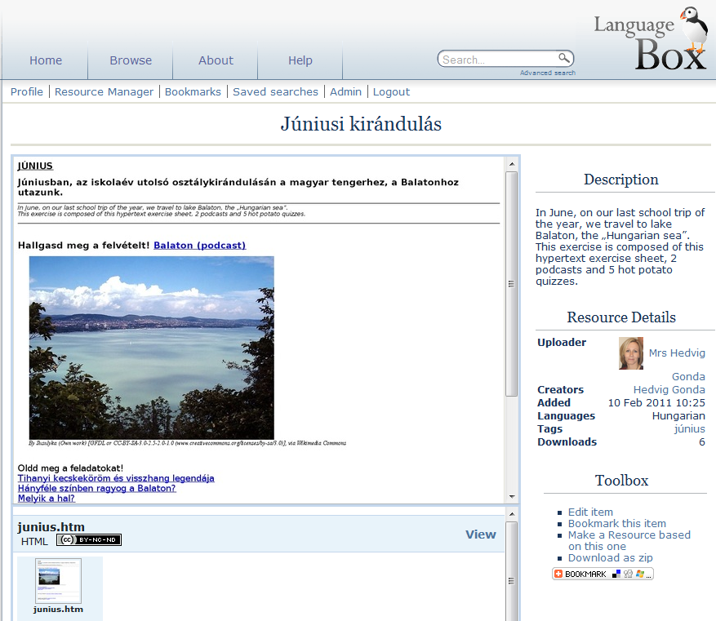

An interactive activity for Hungarian in LanguageBox which comprises audio and interactive tasks: http://languagebox.ac.uk/1736/

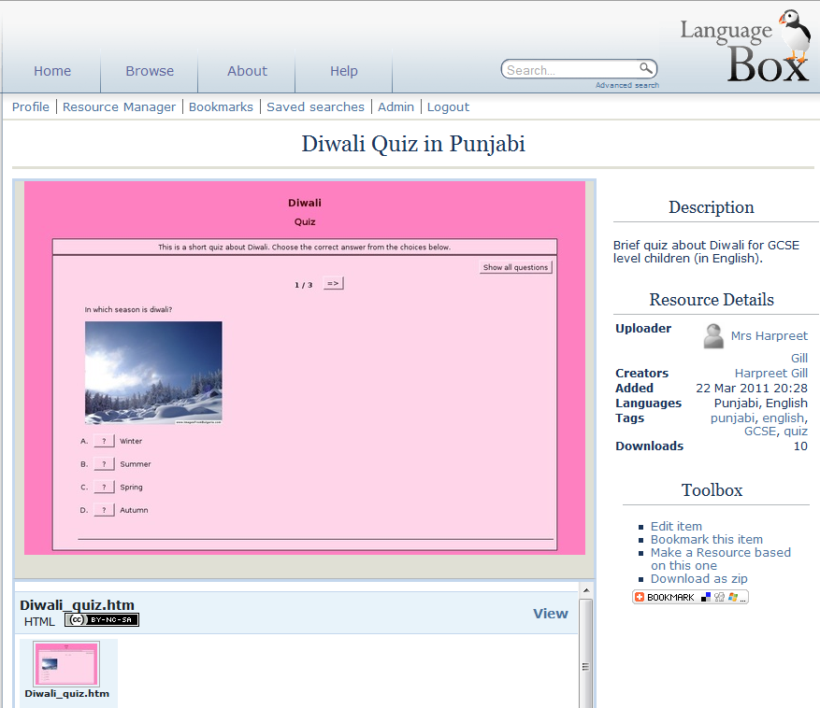

An interactive task for Punjabi http://languagebox.ac.uk/1778/

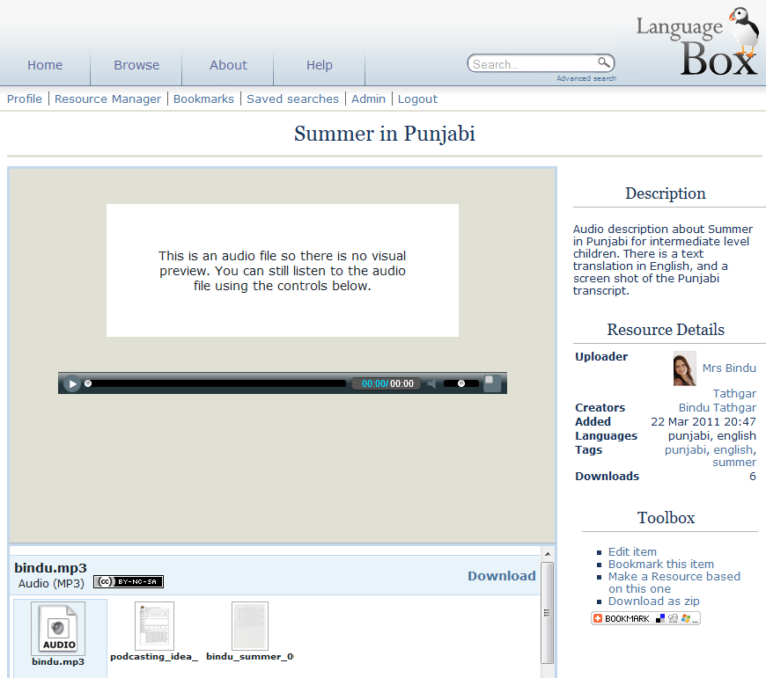
An audio activity with lesson plan, transcript and translation for Punjabi http://languagebox.ac.uk/1779/
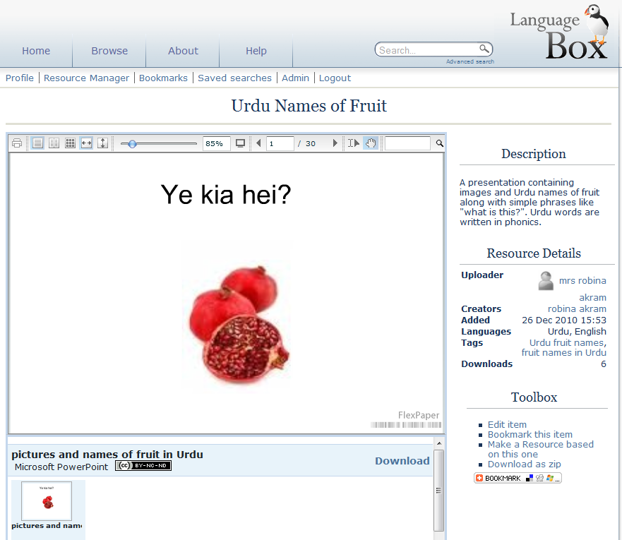

A powerpoint file for use in teaching Urdu http://languagebox.ac.uk/1696/. This was uploaded by one of the teachers from Manchester.

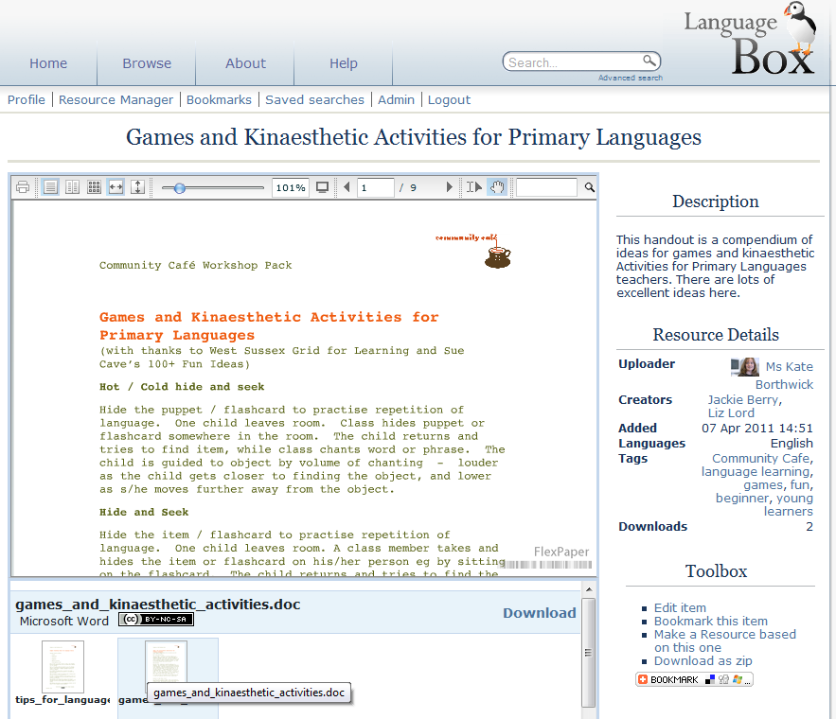

An example of an activity from the Community café workshop pack: this is part of a session on ‘teaching diverse ages/levels in one classroom’.

Appendix B: Evaluation report Community café project
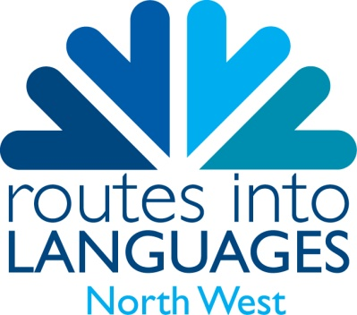

Community Café Evaluation Report
Routes into Languages North West (COLT project)

Background:
When Routes into Languages was established in 2007 the North West decided to shape their regional consortium around community languages, due to the demographic of the area. With a diverse mix of community groups we wanted to draw on the linguistic resources on our doorstep. Our project, also named COLT (Community and Lesser Taught Languages) project, focused on the community languages most widely spoken in the region – Arabic, Urdu, Mandarin Chinese and Italian, as well as promoting all languages more generally.
It has not been easy to establish networks within these community groups, but over the years we have built up strong networks of teachers of Urdu, Arabic and Mandarin. This has been mainly through the Teacher Training programme we ran, supporting teachers who had little or no formal training in how to teach languages.
In addition we have run focus groups and Teachers Symposia, bringing together mainstream and supplementary school teachers; Film Study Sessions in community languages, INSET sessions supporting teachers in using film in language teaching and A Level days for students of these languages.

Working with community groups:
Many of the findings of the Community Café were similar to our own experiences of working with community groups, for example the feeling of isolation many of these teachers feel and the fact that many have never received formal training in teaching.
Through the events and activities we have offered community language teachers over the past four years we have noticed a growing sense of community among the teachers we have worked with. Familiar faces attend our events and friendship groups have formed. When we ran an Urdu focus group teachers commented that they really valued the sense of support they felt when we brought the teachers together, making them feel like they had colleagues to turn to if necessary – even more valuable given the sense of isolation they often feel. This idea of holding a formal session, but with the informal networking being just as valuable, is apparent in the Community Café project.
Under ‘lessons learnt’, LLAS state: “There needs to be more knowledge transfer between HE and school sectors and community languages teachers to enable culture change.” This is something we have been working on in the North West through the COLT Project. We have encouraged links between sectors through focus groups and Teachers Symposia. Also, as part of the Teacher Training courses that we ran, supplementary school teachers spent a day within a mainstream school and found this to be very valuable for observing language lessons and picking up ideas that could be applied to their own classroom. Again this feedback from the Community Café acts as further confirmation that our project was focusing on the right lines.

Evaluation of the Community Café project:
Our involvement in the Community Café project meant that we could once again call our teachers together to offer them some practical workshops. The value of this was three-fold: (i) the teachers were learning practical skills in how to use Language Box and Hot Potatoes software; (ii) the teachers were producing and uploading materials and resources that could be accessed by others particularly those in Southampton involved in the Café sessions and (iii) our teachers were once again able to come together and catch up on how things were going in the various schools and institutions they worked in thus reinforcing the sense of community of practice and facilitating the sharing of good practice across languages.
When we held the workshops you could see the teachers coming together to chat to one another and these were friendships that had come about through the events we offered them. An informal support network had developed which the Community Café has helped to keep going. Over the academic year 2010-11 Routes has received reduced funding and has not been able to offer much support for community language teachers. These Community Café sessions were a chance to maintain contact with the networks we had built. It was clear from their enthusiastic interactions with each other before the session and during the break, how much they valued the opportunity to come together. The networking is almost as valuable as the practical workshop where they learn new skills. This highlights the need for these teachers to meet regularly – and a Community Café setting would be ideal as an informal way for them to come together. This is something Routes North West could consider implementing now that continuation funding has been agreed, although this depends on the criteria set by HEFCE.
LLAS were impressed with the standard of materials our teachers had produced, which we put down to the fact they had all taken part in our COLT Teacher Training course – which had covered material and resource development. This served as further evaluation of our own Teacher Training project, where we could see how far along the teachers had come. It was also a confidence boost to our teachers, who were reassured that their work is good quality and can help support other teachers in Southampton and other areas.
It is a successful outcome for both Routes North West and LLAS that the materials the North West teachers had produced are now being shared with other teachers through the Language Box portal, meaning that more people can access them. Ultimately if teachers are using engaging teaching materials, language learners are enthused and motivation towards language learning improves. This is the ultimate aim of the Routes into Languages programme, so anything which supports the development and dissemination of quality teaching materials is working towards achieving this objective.
On the practical issue of the workshops, these have benefited our community language teachers in the North West as so few CPD opportunities exist for them. Many of the teachers work in supplementary schools, where CPD isn’t offered as the schools simply don’t have the funds – relying on voluntary donations and parental contributions simply to survive. Even for those teachers within mainstream schools we have found that they are not always treated the same as other teachers, sometimes not even being included within the languages department, but seen as offering an extra-curricular activity instead. One Urdu teacher explained how he is timetabled to teach Urdu after school as they can’t find the time for his classes to be included within the usual school day and, from discussions with other community language teachers, this seems to be quite typical for many. This has led to a sense of isolation for many of these teachers and activities such as Community Café provide opportunities they don’t have at school.
So far we have found that activity has to be offered free of charge for the same reasons as outlined above – that the schools don’t have the funds to support CPD for community language teachers. Where we have charged for events we have noticed a very poor uptake. Very little provision is currently offered for these teachers, which is why projects like COLT and Community Café are so valuable – as they fill a gap that currently exists. Projects such as the Community Café can make a valuable contribution to the resource deficit for community languages both in terms of training and materials.

Wider impact of the Community Café project
This project has provided a support network for community language teachers, who often feel isolated. The LanguageBox site particularly has created a feeling that there are other teachers out there who are able to share their teaching resources with colleagues. This project has focused in the Southampton area, with some work in the North West but teachers anywhere can now access the resources these teachers have uploaded.
If further LanguageBox workshops were held across the country more teachers could learn how to upload and share their resources. This would help the community language teachers as the online community would continue to grow and expand.
The idea of a Community Café is beneficial in terms of brining teachers together and providing them with useful workshops and evaluations. If further cafés were held across the country it would ensure support networks were established in a number of areas rather than just Southampton and the North West. These have been shown to be relatively easy to set up – requiring just a room and some refreshments. As I have mentioned earlier, it is not always just the workshops that benefit them, but the chance to meet one another regularly also has a positive impact on community language teachers. Once set up they could look after themselves, with teachers getting together independently to discuss issues affecting them. Based on what I have seen of this project I would certainly encourage other areas to use the Community Café model and roll this out.

The Future
Now that Routes into Languages has received continuation funding for another year, we can develop our work with community language teachers, drawing on the ideas and experience learnt by the Community Café project. Funding is limited but the idea of bringing teachers together does not have to be costly. We would like to implement the idea of a Community Café in the North West – perhaps using the idea of mixing formal and informal by offering a workshop in an area of interest to them and then allowing plenty of time for discussion over coffee and cake. Using university rooms will mean the only costs will be refreshments and these sessions would offer valuable support for these teachers.
Through these workshops we can continue to promote the Language Box as an excellent way for them to share and access suitable teaching resources for community language teachers. This will enable us to keep the networks going in the North West so that once the Routes into Languages funding does run out, there can be some sustainable outcomes in that the networks can continue to meet independently.

http://www.routesintolanguages.ac.uk/northwest
www.languagebox.ac.uk
National Centre for Languages: http://www.cilt.org.uk/community_languages.aspx
http://www.assetlanguages.org.uk/
ibid.
Community Languages in Higher Education: Towards realising the potential, (2008) a report by Joanna McPake and Itesh Sachdev for the Routes into Languages project
http://www.languagecafe.eu

