Let’s play squares: food and drink

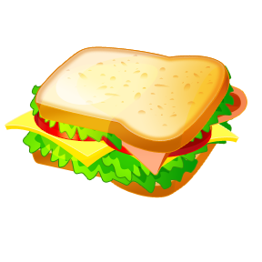

How to Play
- Play in pairs (or 2 pairs against each other) using 1 sheet of squares.
- Each team or player uses a different coloured pencil.
- The object of the game is to connect up 4 boxes with lines joining them to create squares by creating a spoken sentence to link the items in the boxes (this works for any language and teacher can specify the structure that sentences should have): e.g. For practising likes and dislikes: ‘I like tomatoes but I don’t like cabbage.’ ‘I like apples but I detest milk.’ ‘I love sandwiches and I dislike orange juice.’
- Each player or team takes a turn and joins up two boxes by saying their sentence and drawing a line to connect them, then play passes to the other team.
- When a box has been completed, the team that puts the last line on the box, wins that square and puts their initials inside it.
- Teams can ‘steal’ their opponent’s box by completing the last line on it.
- Continue until all boxes on the sheet are connected with squares.
- The winning team is the one that has the most completed boxes.
See below for an example:

A
A

