Guide to using LanguageBox

LanguageBox is a place for you to store and manage your teaching resources, and ultimately, to publish and showcase your work. It is a website which allows you to publish work, and others to download your work.
- Go to http://www.languagebox.ac.uk
- Choose ‘create account’

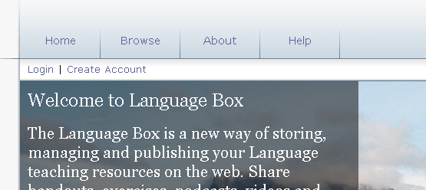
- You will see a screen like this:
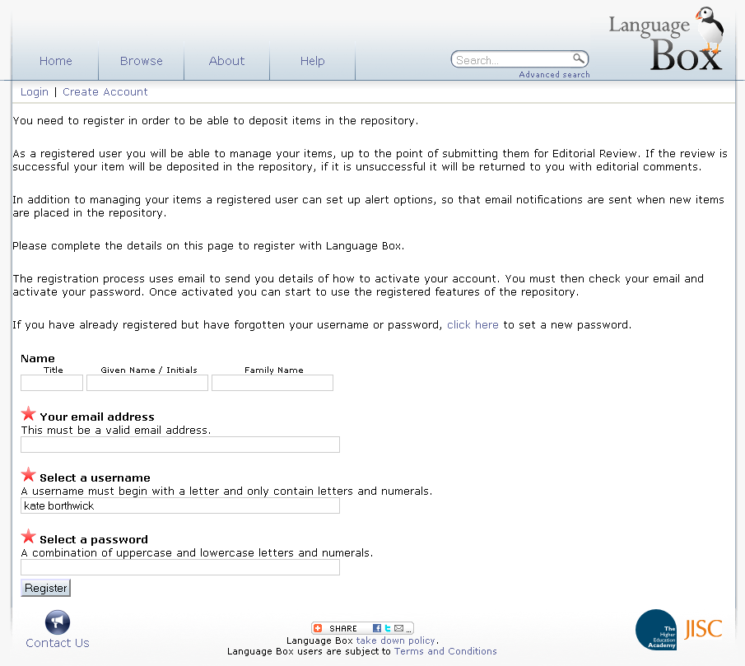

Complete your email address (this must be a valid address); select a username and a password. The starred fields are mandatory. You must also agree to the LanguageBox terms and conditions before you can be registered. Click ‘register.’
- A confirmation email will be sent to the address that you provided. You may encounter a short delay in receiving your information. Click the link in the email to confirm your registration and activate your account. This link will take you to the login screen in LanguageBox:

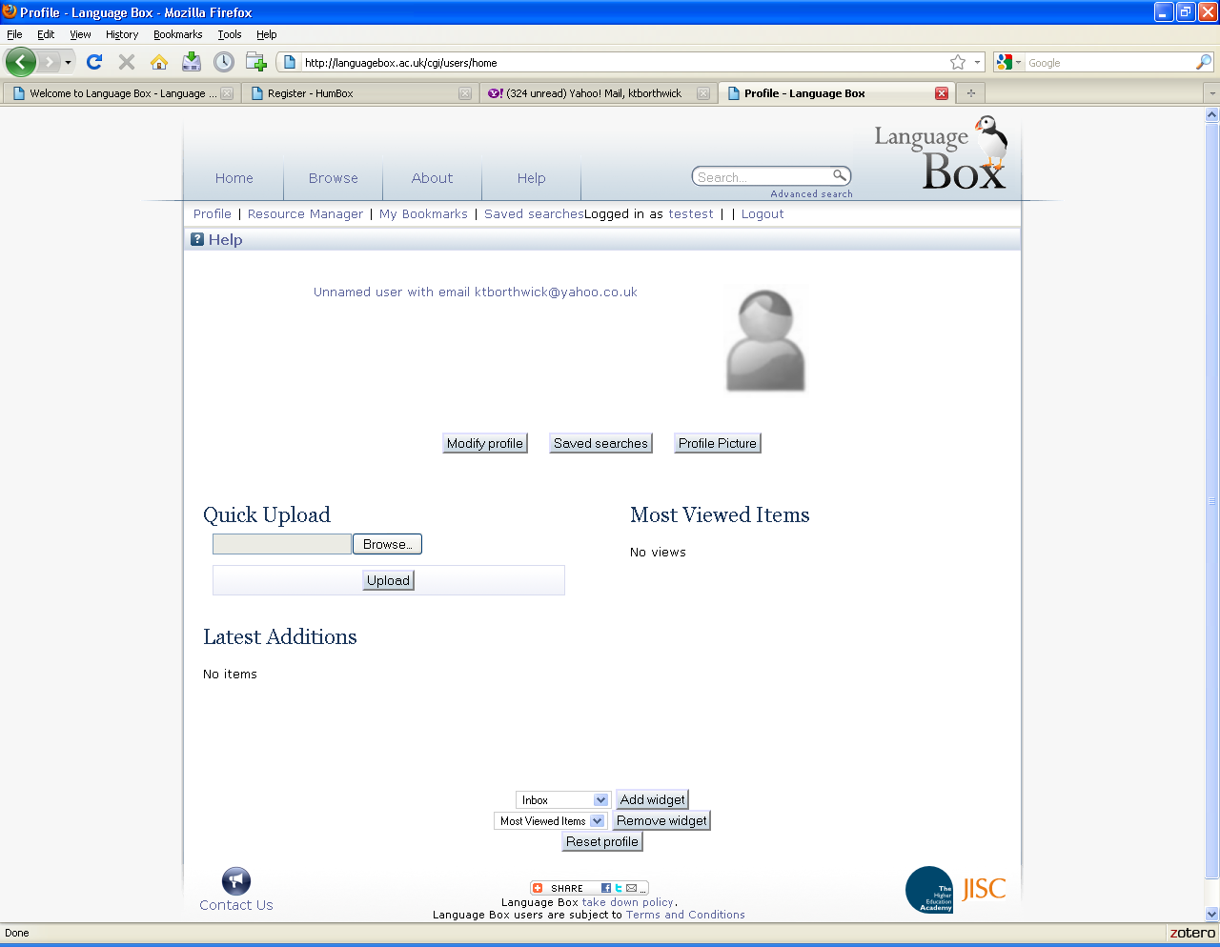
This is your blank user profile screen. Choose the ‘modify profile’ button to add your name and some personal details about yourself. Please provide some information here, as this page is a good guide to your professional life and to the resources that you are uploading. Choose the ‘profile picture’ button to add a picture of yourself. Please add a photo!

Your profile page is where you can see your ‘most viewed’ and ‘most downloaded’ items and where you can see if other people comment on your resources. You can also see which resources you have bookmarked as your favourites.

Uploading your resources:
Now that you have created a profile, you can start uploading resources. Go to ‘resource manager’.

You will see the resource management screen (the files you can see below are files from MY page – yours would be blank until you upload some resources:

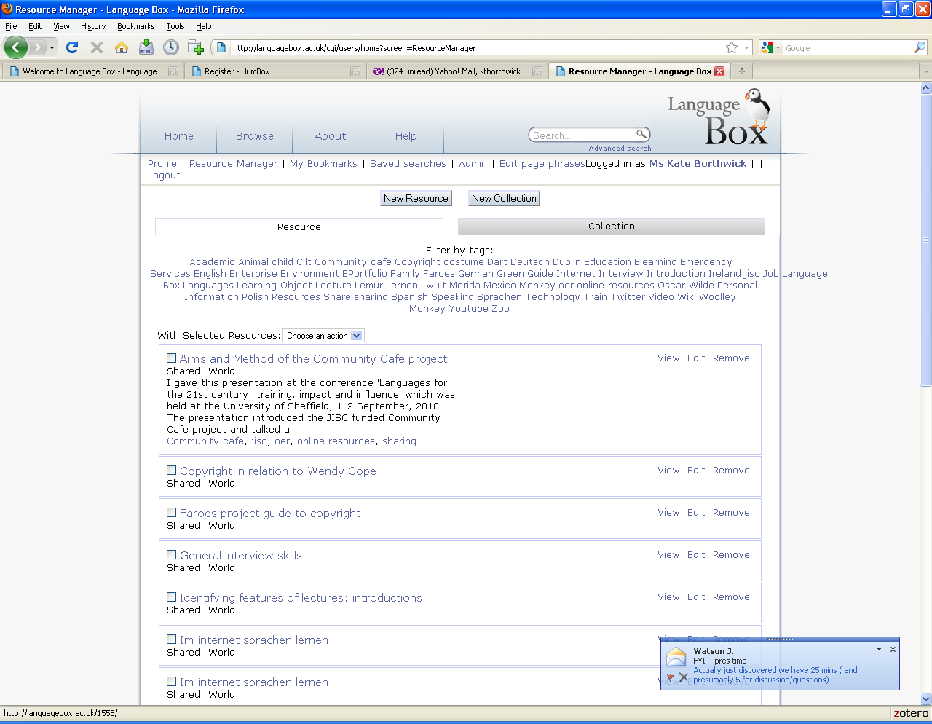
From here you can upload and edit your resources.
Click the ‘new resource’ button. This allows you to upload a single resource. Choose ‘create resource’.

You will see this screen:
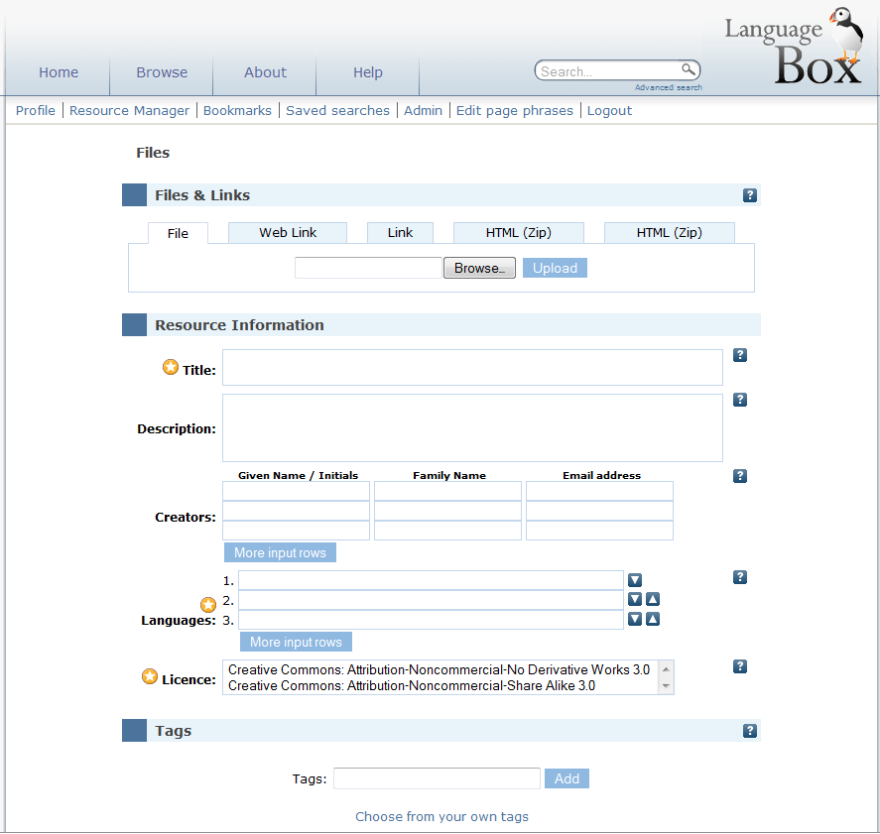

Upload your resource by browsing for it and then choosing ‘upload’. The file will appear on the screen to show that it has been added.

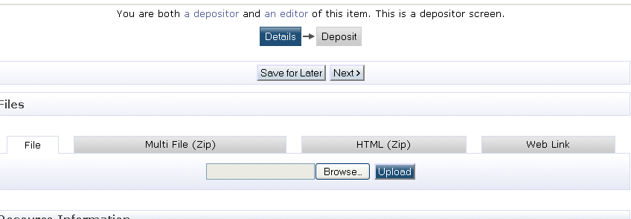

Fill in details about the resource: title, description, information about the creator(s) of the resource, languages and licensing. Add some keyword tags (words which will help others to search for and find your resource), and decide on the viewing permissions for your resource. Advice on how to complete these areas follows below:

Advice on titling:
Try to make your title concise, but also helpful and explanatory to other users. Avoid being too vague or too general.
Advice on tagging:
Try to give useful tags (key words), as these will help users to find your material, for example, think about how you would use the resource, what its main themes are, what activities it might support and what kinds of students you might use it with: e.g. festival, China, reading, vocabulary.
You should separate your tags with commas. You may use phrases e.g. ‘Bengali history’, ‘festivals in Poland’. LanguageBox will automatically capitalise all tags.
Description:
The description of your resource should be intensive yet concise. A good guide on what kind of information to include is to think about what information would be useful to users of LanguageBox to help them to search for, find your resource, and then use it in their own teaching.
Here are some suggestions for the kind of information you might include: what the resource is, e.g. ‘a video of a student telling a story in Chinese’; how you have used the resource in your teaching; an indication of the main themes or content.
Viewing Permissions:
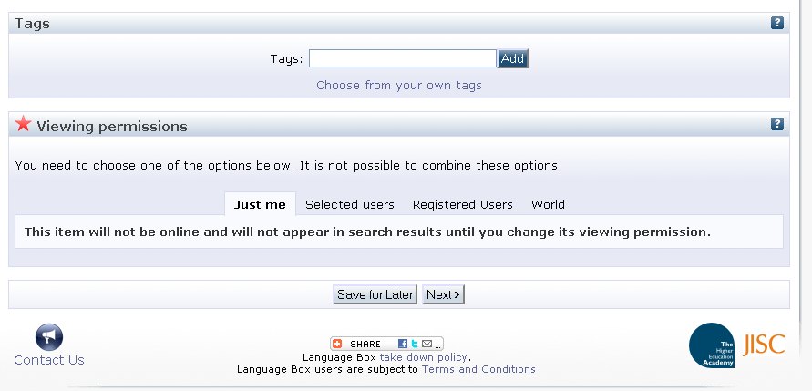
This section of LanguageBox, at the bottom of the page, gives you four options for making your resource visible to users: ‘just you’, selected users, all registered users and site visitors, or to everyone – ‘world.’
You should choose the option ‘world’ for this project, because all material in LanguageBox is designed to be as widely available as possible. If you choose the ‘just me’ option, then only you will be able to see your resource – you might want to do this if you upload a resource that you wish to edit further before making it ‘live’.
Note: If you are uploading a resource for someone else, simply delete your name and type in their name.
Copyright:
There are two options for copyright in LanguageBox, and ideally, we would like you to use the first, which allows users to make the best use of your shared resources:
- Creative Commons Attribution Non-commercial Share Alike, which:
"...lets others remix, tweak, and build upon your work non-commercially, as long as they credit you and license their new creations under the identical terms. Others can download and redistribute your work but they can also translate, make remixes, and produce new stories based on your work. All new work based on yours will carry the same license, so any derivatives will also be non-commercial in nature." See details at: http://creativecommons.org/licenses/by-nc-sa/3.0/

This use of this licence allows users to edit and adapt your work for their own classes.
- Creative Commons Attribution Non-commercial No Derivatives, which:
"…allows others to download your works and share them with others as long as they mention you and link back to you, but they can't change them in any way or use them commercially." See details at: http://creativecommons.org/licenses/by-nc-nd/3.0/
This licence allows people to download and use your resource but not to edit or change it in any way.
Select the licence which you prefer to be attached to your resource. Your selection will be shown on the resource information page. Choose ‘save and finish’ to save your uploaded file and its accompanying information, and to publish them both to the repository.
