Matching exercise planning sheet

Imagine that you are creating a matching exercise to help students learn vocabulary. Students will match pictures to words, or words to words: for example pictures of animals to their name (in the language you are teaching them), or English words to their Bengali/Urdu/Polish etc equivalent.
Write a word in each box below, or describe the picture that should appear there. Next to the box, write the word that you wish to match to the one in the box.
E.g.
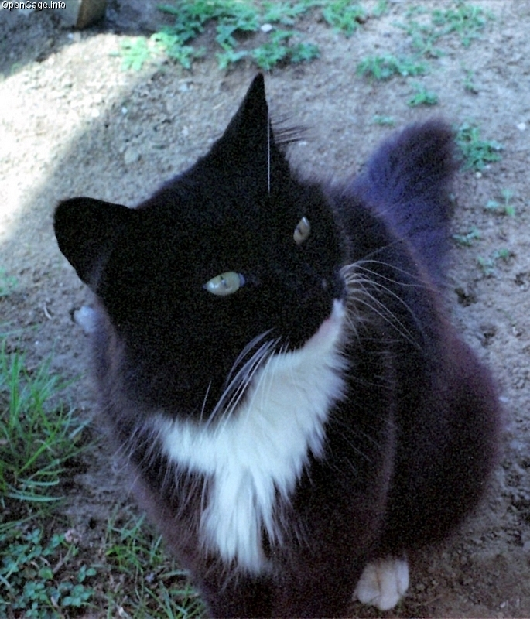  Image courtesy of opencage.info |  | Cat

Plan your activity using the boxes below (continue on the other side if necessary):

