
Community Café: Sharing teaching ideas
Name: | Krystyna Jenvey
Language(s) taught: | Polish
Age(s) of learners: | 6-7
Level(s) of learners: | Beginners |  | Intermediate  x |  | Advanced |  | Mixed ability
Teaching idea  (continue over the page if necessary): | Introduce Polish Customs and Tradition:  - Christmas customs  - Easter customs  - Folk/dance, song, regional dress  - Folk art  - Polish National Anthem  - Symbols of Poland  - Famous people  - History events  Encourage students to learn and appreciate Polish culture to know fames people and tradition; through songs, dance, poems, play, drawings and listen to music  Photos below of the Polish Dance and Singing Group Karpaty based in Southampton, and students from Polish School.  Polish folk costume has been widely recognized as an important part of the heritage of traditional peasant culture.  The traditional costumes are usually worn on festive occasion.  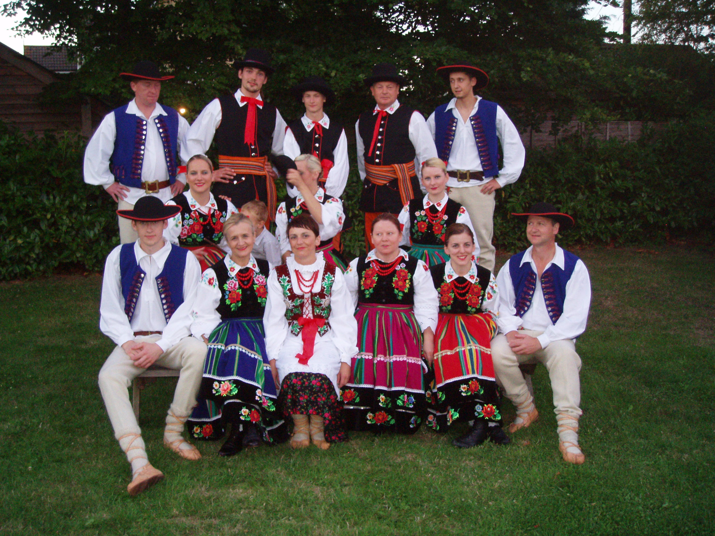  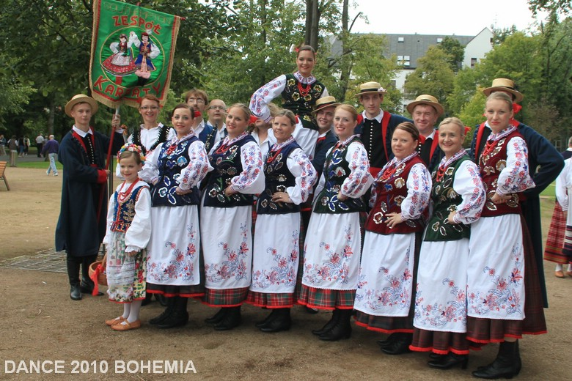  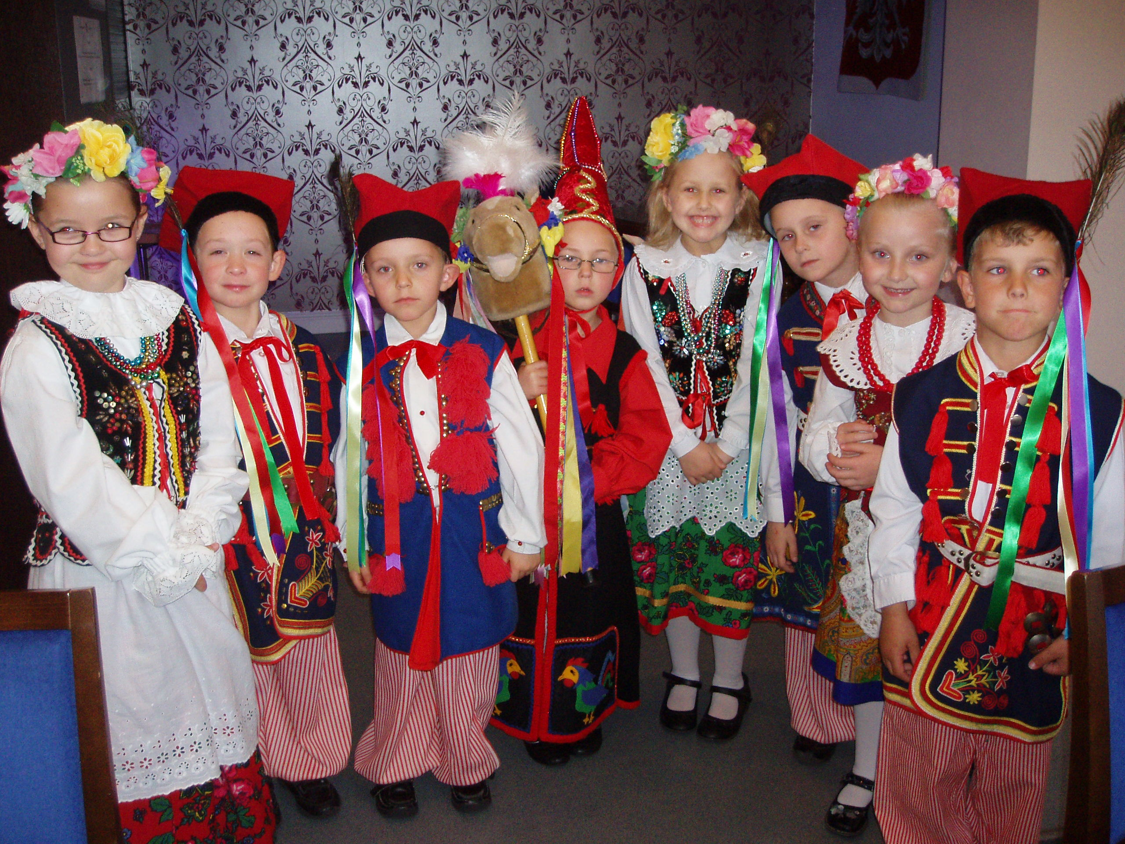
Resources (these might include materials you want to create): | Music CD, traditional costumes, songs, poems, books, photos, pictures, pens, colouring pencils etc..
Language skill: | Reading | Writing |  | Speaking | Listening | Grammar |  | Vocabulary
Keywords: | Building confidence and knowledge of Polish customs and culture

