Ok, going through this stage-by-stage for you.
First thing when I log onto Sussed, I find the Noticeboard to be a complete waste of space. I don’t look at it for more than half a second, and always go straight to my inbox. It never seems to be remotely relevant to me – a lot of the notices are for staff. I do worry that perhaps I miss a couple of things that are relevant to me because I’ve given up looking through the notices, but I generally find it to be too time-consuming to sift through. Can a filter be introduced for notices by type? Staff/student, UG/PG, Humanities/Sciences/Engineering etc?

Next – I have no idea what this Group function is. Possibly it is used in other subjects, but to my knowledge Humanities have no idea of what it is, what it does, or what use it could be, as it has never been mentioned to me. It appears twice on the Home page – firstly in the left-hand side bar, informing me there has been no recent activity in my groups (but I assume I’m not part of any?!), and then again as a personal shortcut in the top right.

The Bookmarks section in the top left I find confusing and of little use, and it took me a while to work out that ‘Personal’ meant my personal information and that actually this was quite an important tab after all. Shouldn’t this be at the very top right with my shortcuts?

It’s only at this moment, appraising Sussed, that I find I look at the Sample tab for the first time. I have never ever looked at it before, nor had a clue as to what the term ‘Sample’ referred to in this case.
In fact, it is safe to say the only tabs I use in Sussed are Library, Email, and Programme. I use the HIP which is technically one of my tabs, i.e. School, but hadn’t really registered that it was a tab on Sussed, so used to just Google it, and now have it bookmarked.

On the Library tab, I mainly only use Resources (under Resources and Support), and Webcat (under Catalogues). It’s nice to finally have our Sussed/Blackboard username and password linked to the Library login. It never made any sense to me that we had to use our Student number and a random 4-digit number for login. What would be great with the library though, would be that we each had a proper library profile to go alongside this, where we could at least see a digital list of everything we had taken out on loan at any one moment, and when it was all due back. Currently, all one has is a printed paper receipt, which is easily lost, and when you’re taking out up to 10 or 20 books at any one time, it’s easy to forget what you have out and when it needs to be back. Clearly, the library has a digital system that knows what books I have out, shouldn’t I know too? If there is such a system in place for students, I certainly haven’t been made aware of it.
I believe the library was testing digital renewal of loans. If this was to roll out across the university, that would be sweet.

I generally get on fine with Email. My main gripe is just how tiny the storage space is, at least for me as a humanities student. For example, I had a clearout of my inbox the other day, got rid of almost everything but some stuff I still needed, and I was apparently still over the limit! And the harassing automated emails I receive every day are completely ineffectual, since I find there is little more I can do to reduce my space usage, so these emails I delete without reading, like other spam. If anything, surely they just take up more of the space that they complain I am using too much of? Having said that, only today did I discover that I had never emptied my Sent box, which probably had quite an effect on this. I get the feeling most people forget about their Sent boxes. Speaking of spam, it would be helpful to have a tool like other email clients, that would let me decide whether emails I receive should automatically be sent to the Junk box (again, if there is one I haven’t found it). There are a couple of mailing lists I’m signed up to that won’t unsubscribe me despite my attempts to do so, so being able to send straight to Junk would be handy.

I have just been reminded of something that irritates me – the tendency of Sussed to time me out at home and cause me to log in again. Damnit, I’m at home not on a public computer, I shouldn’t need auto log out for security reasons. I trust the people I’m living with. This becomes especially irritating if you’ve been writing a long email or adding many attachments to an email, only to find that when you come to send it, you have been timed out and must start all over. I don’t know whether that has been fixed, but that has certainly happened to me in the past.

The Programme tab is quite useful. I mainly only use it to check my weekly timetable, but having the exam timetable there is also useful. The ‘Courses I’m attending’ section is quite useful, but would be better if it could be kept up-to-date. Possibly it’s just my subject that’s slow that way, but I’ve often found that it’s showing modules from the previous year.

The Blackboard website, I have similar gripes with as just mentioned: namely, that it is not kept up-to-date. This isn’t so much a problem with the IT as with policy. I think there should be more university policy insisting that staff should keep their course sites on Blackboard up-to-date. You can tell when staff are more or less tech-savvy, because their module pages will be full or empty:

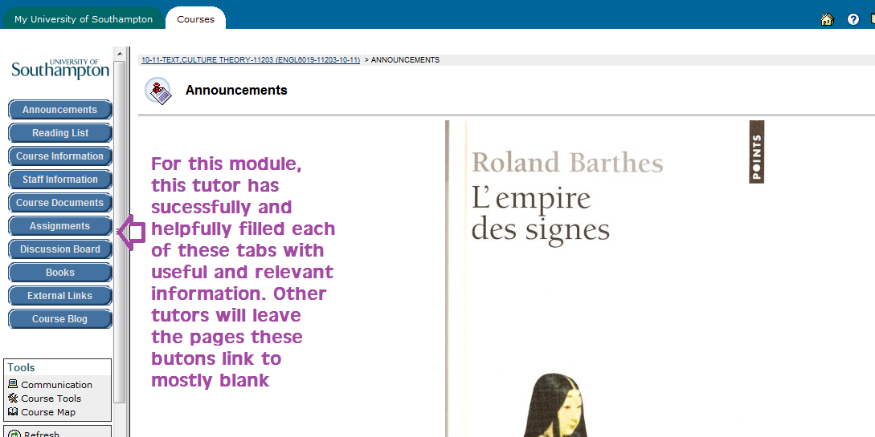

I very much appreciate the digital hand-in system through Blackboard, although in the past, digital coversheets have been a bit of a nuisance (I know Kim’s discussed that one with you before). It made everything so much more convenient. Alas, it appears now I’m on the masters course, I have to hand in everything in paper once again, and I don’t really know why.

The Humanities Portal (HIP) I find mainly does contain the information I need, but is fiddly to navigate. For example, from the home page I go to the English page, and from there, to find the module options for my MA, I would expect to go to the postgraduate page. However, I have found that this only leads to a description of my course and not a break-down of the units, so I actually have to go to the undergraduate section to find this list of modules and their descriptions.

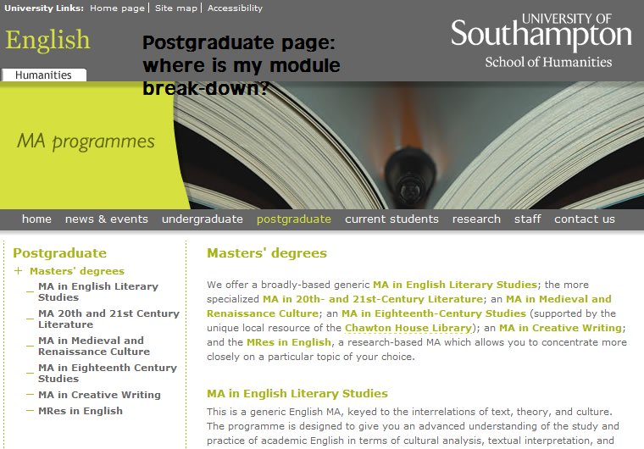
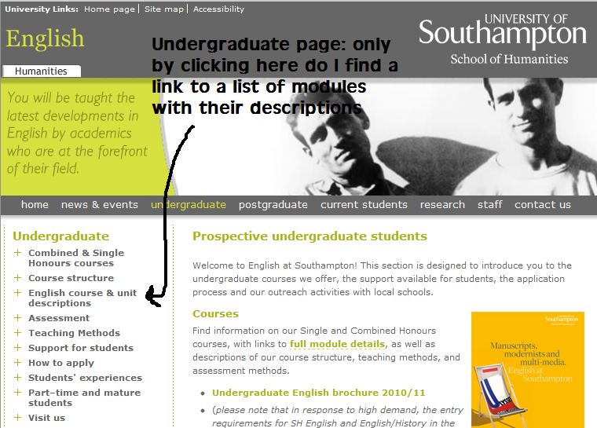

That link takes me to here, which actually has information for everything:

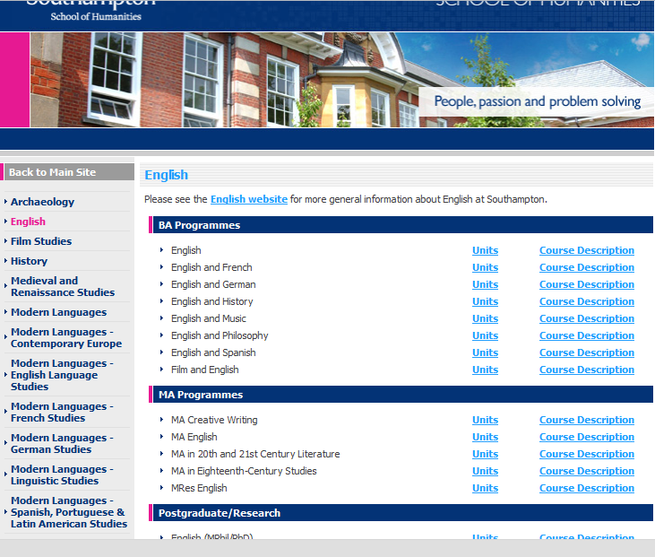

This theme goes on. It is awkward to navigate around this website. A couple of times I have stumbled upon the information I really need, but as it is right now, I’m still not sure where to go to download the document I need to apply for my module choices.

IT over all? You must’ve heard the complaints about there being too many Webcat computers and not enough ISS in the library. This also bugs me. The internet connection at any internet café zones (e.g. the library, the SU) is so slow it barely makes it worthwhile its being there. On the other hand, I really appreciate how one can log in at any printer and print off documents you sent from a computer; it means that if one printer is busy you can just find another one. I also appreciate the fact that it is basically one login for everything – I know a guy whose university system was not at all sychronised, which resulted in having to have something like 6 different usernames and passwords.

